New Approaches for the Conservation Genomics of the
Genus Cycas L. in Australia

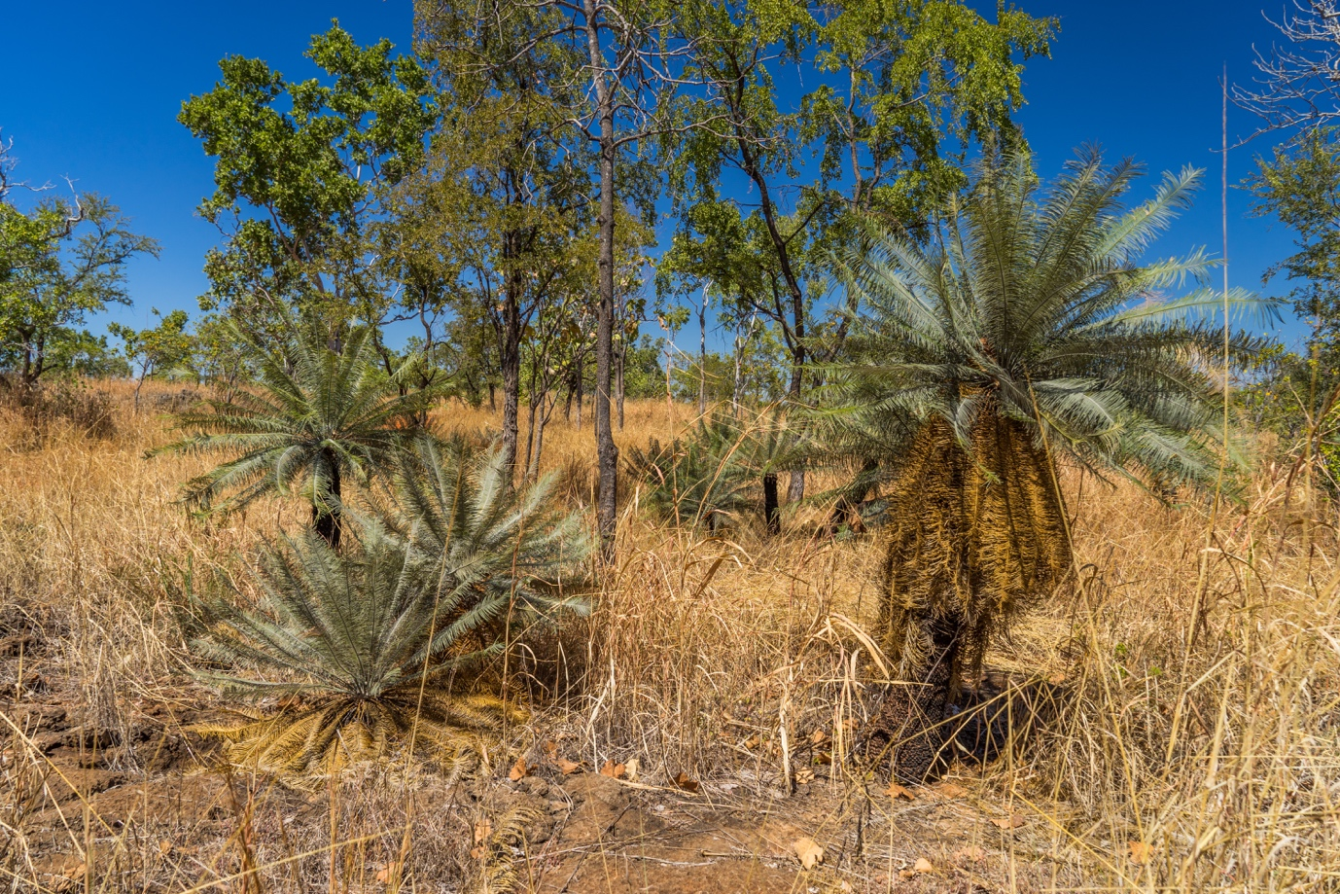

James A. R. Clugston and Marco F. Duretto,
Plant Diversity, Royal Botanic Gardens and Domain Trust.

Final report submitted to the Australian Flora Foundation in fulfilment of grant received by N Nagalingum (then Royal Botanic Gardens & Domain Trust, Sydney, Australia), 2015-2019

Declaration

I declare that this report submitted to the Australian Flora Foundation has been composed solely by myself, James A. R. Clugston, in collaboration with Nathalie S. Nagalingum and Murray Henwood. Except where states otherwise by reference or acknowledgment, the work presented is entirely my own.

The research presented here was part of a final dissertation for the award of Doctor of Philosophy submitted to the University of Edinburgh in October 2019, which was successfully awarded. Currently one of three planned papers have been published from this project in Molecular Ecology Resources.

James A. R. Clugston

____________________________

6 January 2020

New Approaches for the Conservation Genomics of the
Genus Cycas L. in Australia

James A. R. Clugston, Murray J. Henwood and Nathalie S. Nagalingum.

Abstract
Cycad species exist as small fragmented populations, therefore understanding their genetic variation is imperative for their conservation to ensure their long-term survival. Genetic data plays a fundamental role in identifying genotypes and detecting populations with the highest genetic diversity. This project uses next generation sequencing (NGS) and restriction associated DNA sequencing (RADseq) to identify thousands of genome-wide polymorphisms from populations of selected cycad species from the Northern Territory, Australia, namely: Cycas armstrongii, C. calcicola, C. maconochiei subsp. maconochiei and the putitive interspecific hybrid C. armstrongii x maconochiei. RADseq was used to determine intra- and interspecific genetic variation in populations, verify the putative hybrid, recognize populations of conservation priority and determine if botanic garden collections currently represent the genetic diversity inherent in the wild. Cycas calcicola showed very low levels of genetic diversity and high inbreeding, and although there was significant geographic partitioning between populations in the Katherine and Litchfield National Park regions, which correlated with genetic differentiation. Additionally, the results showed that C. calcicola was not genetically, well represented in ex-situ collections. The genomic diversity of C. armstrongii, C. maconochiei subsp. maconochiei and C. armstrongii x C. maconochiei differs from that of C. calcicola and shows very low levels of genetic diversity yet generally with lower levels of inbreeding. The results show little genetic distance between C. armstrongii and C. maconochiei subsp. maconochiei, the most likely explanation is that they represent morphological extremes of a single species. The results from RADseq have far reaching significance for the conservation of cycads. In the case of C. calcicola, a far more structured acquisition of genetic material will be required if the full genetic diversity of this species is to be preserved in ex-situ collections.

Introduction

The risk of extinction in plant species is increasing worldwide due to habitat fragmentation, climate change, land clearance and, in some cases, over-collection from natural populations (Newbold et al. 2016). The introduction of invasive species adds further pressure to wild populations by sometimes outcompeting native species (Vilà et al. 2011). Because of these pressures imposed upon natural populations, their conservation is becoming ever more important to help preserve biodiversity (Hefley et al. 2016). Cycads have the highest risk of extinction of any group of seed plants, so their conservation is of paramount importance (Donaldson 2003).

Cycads (Cycadales) represent the oldest group of extant seed plants (Nagalingum et al. 2011). They consist of 351 accepted species in 10 genera from two families: Zamiaceae and Cycadaceae (Calonje et al. 2019). Cycadaceae is monogeneric with the sole genus Cycas L. Cycas is the largest genus of Cycadales, consisting of 117 extant species. The genus has a pantropical distribution and is found in Madagascar, throughout Asia, the Pacific Islands and Australia. Australia represents a biodiversity hotspot for cycads, where Cycas is represented by 38 species. The Australian species are distributed throughout Northern Australia including; Western Australia (three species), the Northern Territory (16 species) and Queensland (19 species).

Most parts of cycads are poisonous to livestock, including the leaves, sap, and seeds (Norstog & Nicholls 1997). This toxicity has often caused them to be cleared from arable land in order to limit accidental poisoning (Hall & Walter 2014; Hall & McGavin 1968). Cycads are also highly prized in horticulture, with some species being sold for thousands of US dollars (Donaldson 2003). The ornamental appeal of cycads has generated a great demand, causing over-collection and illegal removal from wild populations (Torgersen 2017; Pérez-Farrera et al. 2006). These factors cause breaks within and between populations leading to fragmentation. Fragmentation can prevent gene flow and further exacerbate isolation, leading to high genetic differentiation between populations, with a risk of increased inbreeding within the fragments (Young et al. 1996).

The increasing range and intensity of threat means that the in-situ conservation of many plant taxa is becoming increasingly urgent (Whitlock et al. 2016). As a result, many botanic gardens have made it their mission to play a critical role in the conservation of species (Nikitsky Botanical Gardens 2017). The living ex-situ plant collections of botanic gardens can harbour a significant amount of genetic diversity, representing that of natural in-situ populations
(Cibrian-Jaramillo et al. 2013; Dosmann 2006). Thus, these ex-situ collections can be used to conserve genetic diversity of wild populations (Fant et al. 2016).

It is critical to consider targeted collection of genetic material from natural populations for conservation purposes (Griffith et al. 2015). With careful management, botanic gardens can successfully be used to conserve wild populations (Griffith et al. 2014). Genetic diversity representing natural populations can be introduced into ex-situ conservation collections, and in some cases, has the potential to help replenish the genetic reserves of depleted natural populations (Volis 2017). Seed banks are considered to be a cost-effective method by which to store the seeds of most plant species almost indefinitely (Hamilton 1994), and have the capability of maintaining genetic diversity of species. Seed banks are not, however, an option for plants such as cycads the seeds of within have a very short period of viability (<1 year) under conventional storage regimes (Calonje et al. 2011; Nadarajan et al. 2018; Mondoni et al. 2011). The only way to conserve cycads ex-situ is through living plants, but to do this effectively we need to understand the genetic diversity of the populations (Hurka 1994).

Conservation genetics provides a framework to guide both conservation and restoration to minimise the risk of extinction imposed upon species like cycads (Kramer & Havens 2009; Frankham et al. 2004). The long-term aim of conservation genetics is to understand the genetic variation in wild populations, and to determine if populations contain enough variation for future adaptation, expansion and reestablishment (Paz-Vinas et al. 2018; Yoder et al. 2018; Hedrick & Miller 1992). Many in-situ conservation plans have been informed by measuring genetic factors that affect the overall dynamics of populations, such as decreases in population size, past bottlenecks and sex-specific gene flow (Zhang et al. 2018; Ahrens et al. 2017). Conservation genetics has also been used to identify populations with high levels of genetic diversity, and to help select which of these populations should be prioritised for conservation (Hou et al. 2018; Rodríguez-Rodríguez et al. 2018; Drury et al. 2017).

However, despite the effectiveness of in-situ conservation is not optimal for all plant groups (Fay 2018), and many conservation genetic studies on cycads have focused on species already at high risk of extinction, biasing results (Swart et al. 2018; Feng et al. 2014; Da Silva et al. 2012; Pinares et al. 2009; Long-Qian & Xun 2006). This is the case for many cycads with populations that are already showing declines in genetic diversity (Cabrera-Toledo et al. 2012; Da Silva et al. 2012; Octavio-Aguilar et al. 2009; González-Astorga et al. 2008; Shuguang et al. 2006). The results of these studies showed that cycads exist in small and fragmented populations, especially in Africa (Da Silva et al. 2012; Ekué et al. 2008) and Central America (Cabrera-Toledo et al. 2010). This fragmentation is reflected in the genetic diversity where populations show evidence of drift resulting in a loss of alleles (Zhan et al. 2011; González-Astorga et al. 2008).

Geographic isolation often results in high genetic differentiation between populations (Long-Qian et al. 2004; Keppel et al. 2002). Populations connected by gene flow usually have greater gene diversity but overall lower genetic differentiation. This is because the populations are less genetically differentiated and, therefore, similar genetically (Huang et al. 2004; Yang & Meerow 1996). Over-collection and land clearance reduces the effective population size, increases homozygosity of a population due to inbreeding, and slowly reduces the overall genetic diversity of the species (Meerow et al. 2012; Long-Qian et al. 2004). However, genetic diversity in cycads is not always correlated with the size of the populations, as smaller and isolated populations can contain high levels of genetic diversity, despite population retraction (Gong et al. 2015). This is likely due to historic gene flow caused by the slow reproductive times in cycads, and is often correlated with low variation between populations (James et al. 2018; Cibrián-Jaramillo et al. 2010; González-Astorga et al. 2008).

Australian populations of Cycas are often large and less disturbed (Liddle 2009) compared to those of other countries. Of the 38 species of Cycas in Australia, only one study into the conservation genetics of an Australian Cycas has been conducted (James et al. 2018). This makes Australia a prime location in which to further develop an understanding the population genetics, and evolutionary processes and patterns of cycads.

Here we investigated the genetic diversity of four taxa in the genus Cycas that were found in close proximity to each other; Cycas armstrongii Miq. (Figure 1), C. calcicola Maconochie (Figure 2), C. maconochiei Chirgwin & K.D. Hill subsp. maconochiei (Figure 3) and a single hybrid population C. armstrongii x C. maconochiei occurring in the Northern Territory Australia using genetic material collected from natural populations and from ex-situ collections of botanic gardens. The other subspecies of C. maconochiei, C. maconochiei subsp. viridis is geographically isolated from the taxa of this study and fell outside the scope of this study. To do this was used for next generation sequencing in the form of RADseq, which allowed us to find informative markers throughout the genome of C. calcicola. The retrieved markers were either neutral or non-neutral, and subject to the full evolutionary history of the species (Andrews et al. 2016). The genetic data were used in two areas: firstly, to investigate the genetic diversity within and between populations of the Litchfield and Katherine regions for C. calcicola, where the majority of the populations are found; secondly, to determine if the ex-situ collections adequately represent the genetic diversity of the wild populations. For Cycas armstrongii and C. maconochiei subsp. maconochiei we use genetic data to determine the genetic history and diversity of natural populations, and provide new insights into the geographic and genetic relationship between the two species, that will allow us to examine the occurrence of the interspecific hybridisation proposed by Hill (1996).

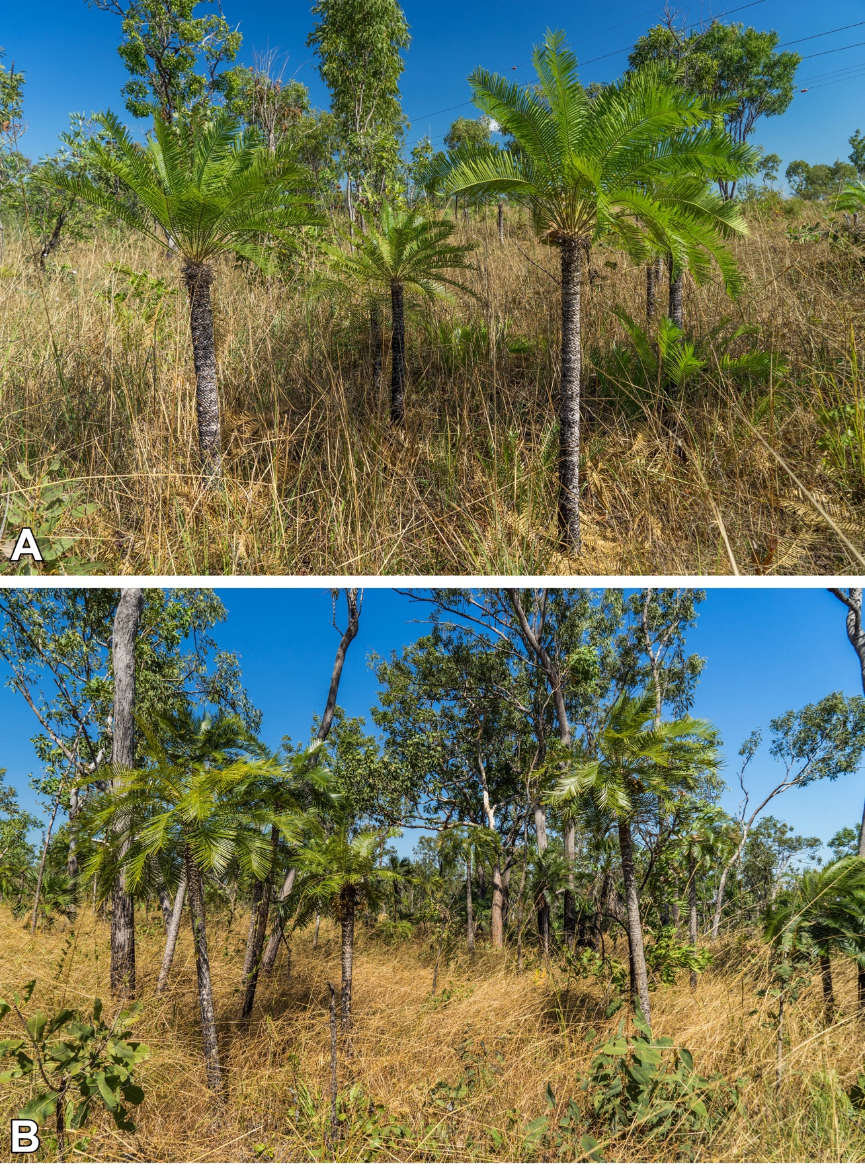
Figure 1 Cycas armstrongii. populations growing in the Darwin Coastal and Pine Creek region, Northern Territory Australia. (A) Small population growing along the Stuart Highway, in the Darwin Region, Northern Territory Australia. (B) Medium sized population consisting of mostly mature specimens growing near the Litchfield National Park.
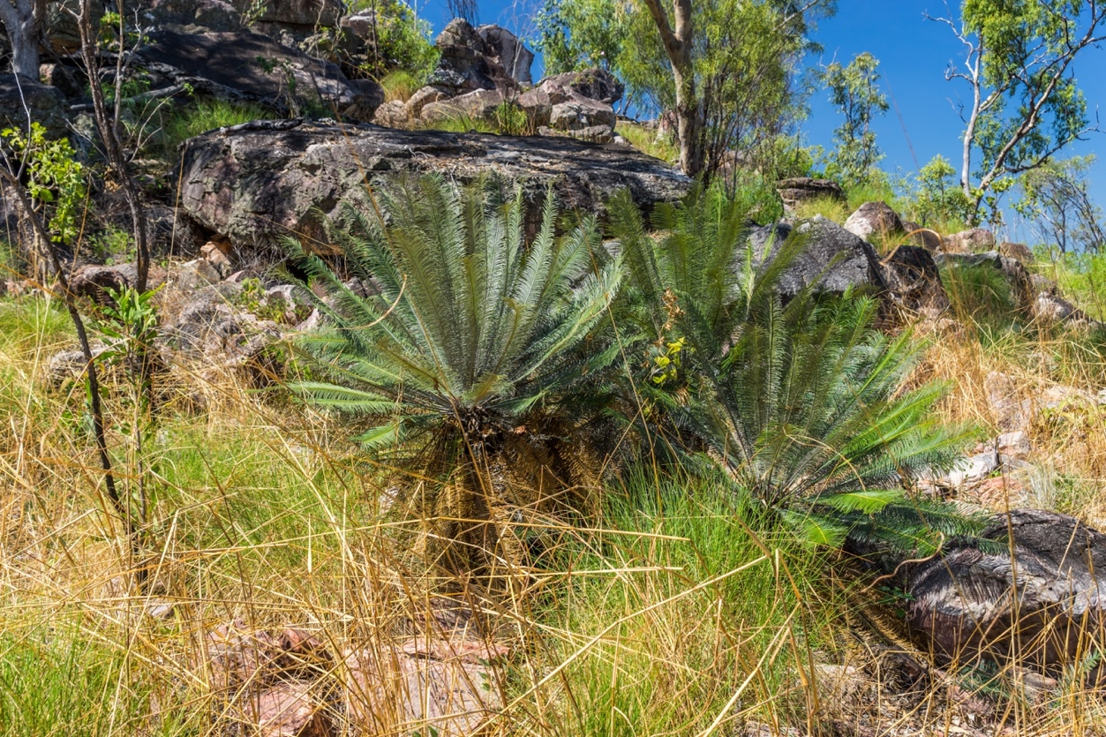
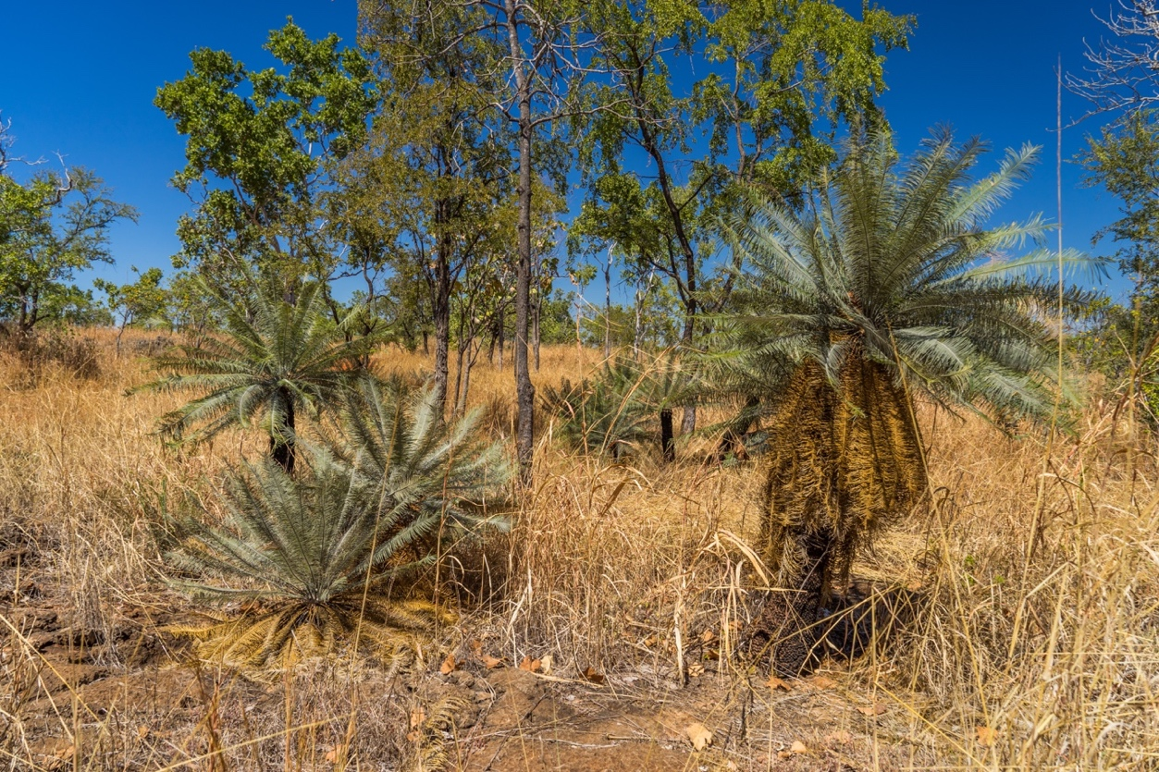
A

B

Figure 2 Cycas calcicola populations growing in the wild in the Katherine region and Litchfield National Park. (A) Part of a large population of C. calcicola growing on sandstone in the Litchfield National Park, Northern Territory. (B) Small group C. calcicola growing on limestone in the Katherine region.

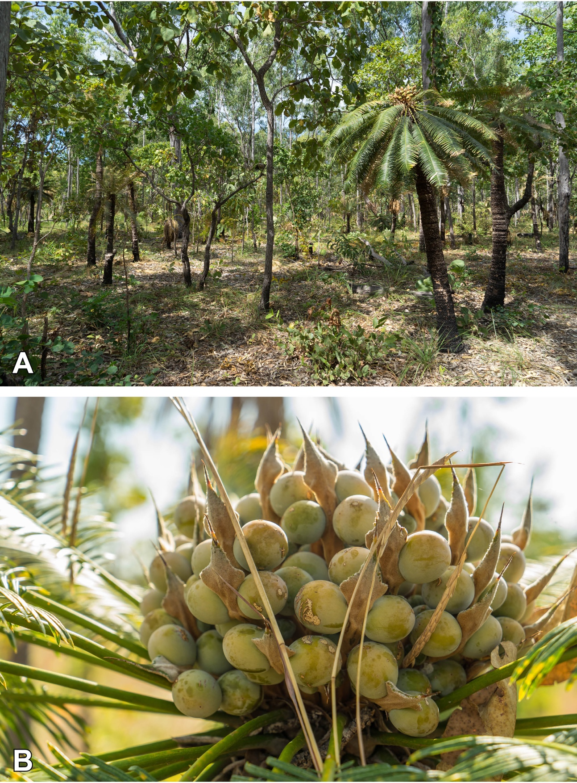
Figure 3 Cycas maconochiei subsp. maconochiei growing in the Cox Peninsula Northern Territory Australia. (A) Large population of C. maconochiei subsp.maconochiei (B) Large mature female specimen bearing seeds on megasporophylls.

Materials and methods

Sampling strategy. Silica-dried leaflets of Cycas calcicola were collected from wild populations within Litchfield National Park and the Katherine region in the Northern Territory, Australia. Populations were selected based on herbarium specimens and The Australasian Virtual Herbarium (AVH; https://avh.chah.org.au, accessed 12th January 2015). A total of 60 individuals were sampled from six populations: three populations from Litchfield National Park and three from the Katherine region (Figure 4). For each population, ten individuals were sampled from plants of varying ages (juvenile to mature) and bearing microsporangiate or megasporangiate strobili, In addition, a further 12 samples were obtained from cultivated ex-situ collections: George Brown Darwin Botanic Garden (Darwin, Northern Territory, Australia) and Montgomery Botanical Center (Miami, Florida, USA). The ex-situ conservation material came from plants of known wild origin and represented the Katherine, Daly River, and Spirit Hills populations. In addition to the tissue sampling, we also gathered basic population demographics, which were recorded for each population (Table 7).
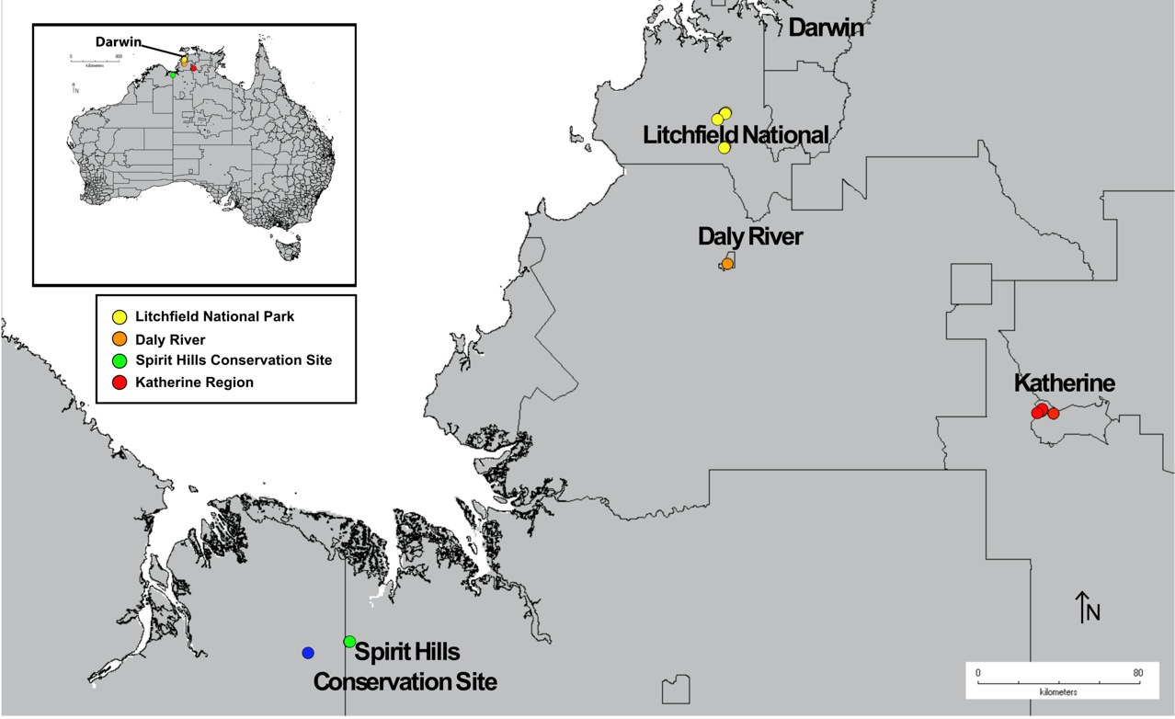

Figure 4 Distribution of samples of C. calcicola in Northern Territory. Map of northern region in the Northern Territory, Australia showing sampling sites of wild (Litchfield and Katherine) and ex-situ conservation collections, representing the entire range of the species (Spirit Hills and Daly River).
For Cycas armstrongii and C. maconochiei subsp. maconochiei populations were selected based on previously published records by Liddle (2009), Dixon (2004) Hill (1994), herbarium specimens held by The New South Wales National Herbarium (NSW), Northern Territory Herbarium (DNA), and The Australasian Virtual Herbarium (AVH) ( https://avh.chah.org.au, accessed 12th January 2015). Silica gel dried leaflets were collected from up to 40 individuals (Average =12) from 21 wild populations (Table 11, Figure 10) for two species: Cycas armstrongii and Cycas maconochiei subsp. maconochiei, and a population of suspected hybrid individuals (= Cycas armstrongii x C. maconochiei). The sampled populations represent the following biogeographic subregions as defined by the Interim Biogeographic Regionalisation for Australia (IBRA7; Australian Government 2000): Darwin Costal (DAC01), Pine Creek (PCK01) and Tiwi (TIW01) and Cobourg (TIW02). A population of C. maconochiei from the Daly Basin (IBRA subregion DOB01) was not sampled.
Figure 5 Map of samples collected for Cycas armstrongii and C. maconochiei subsp.maconochiei. Map of Northern Territory, Australia. Showing range of sample collection from C. armstrongii (Tiwi Islands, Garig Gunak Barlu National Park, Darwin Coastal Region and Litchfield National Park (Pine Creek)), C. maconochiei subsp.maconochiei (Cox Peninsula to Dundee Beach, representing most populations expect most southern), representing most populations expect most southern and a hybrid population C. armstrongii x C. maconochiei.
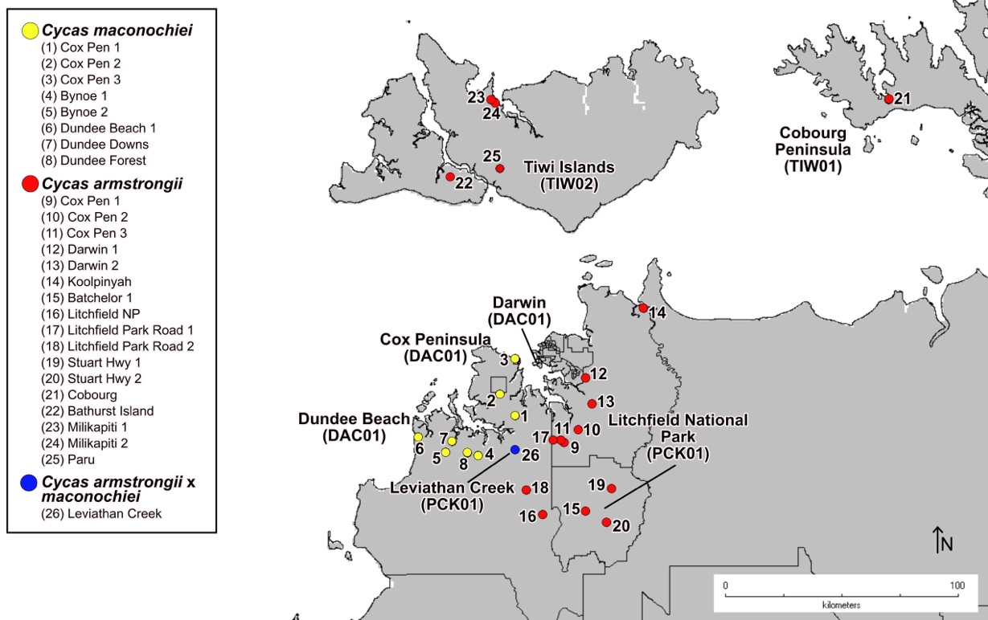

DNA extraction and quantification. Approximately 0.05 g of silica-dried leaflets were ground to a fine powder using a TissueLyser (Qiagen, Hilden, Germany). When present in large amounts, trichomes were removed using a wire brush to improve extraction yield (common with C. calcicola). High molecular weight genomic DNA was extracted using a DNeasy Plant DNA Extraction Mini Kit (Qiagen, Hilden, Germany). Genomic DNA was inspected using a 2% agarose gel to check for the presence of DNA and impurities. DNA extractions were quantified using an Invitrogen Qubit broad range (3.0 BR DNA assay; Invitrogen, Life Technologies, Carlsbad, CA, USA) fluorometer with a target concentration of 17 µg/mL; any sample that yielded less than 17 µg/mL was either re-extracted or concentrated using a 1:1 ratio of Agencourt AMPure XP sample purification beads (Beckman Coulter, Inc.) by combining multiple extractions.

DNA normalisation and restriction digest reaction. For a full protocol, see Clugston et al. (2019). First, genomic DNA was normalised to a concentration of 500 ng in 42 µL total volume (0.01 µg/mL). Second, 5 µL of NEB 10x CutSmart buffer (New England Biolabs, Ipswich, MA) and 1 µL of Bovine Serum Albumin (BSA) was added to each well. Samples were then held at 4°C for a minimum of five hours before adding restriction enzymes—the five hours of incubation helped the cutting action of the restriction enzymes. Next, double digest reactions were carried out using 1 µL each of the restriction enzymes EcoR1-HF and Mse1. Reactions were then placed into a thermocycler for three hours at 37°C with a final 20-minute enzyme deactivation step at 65°C. The reactions were then checked on 2% agarose gel for quality of digestion. Last, reactions were cleaned using 1.8:1 ratio of AMPure XP beads to sample (90 µL of AMPure XP beads to 50 µL of digested DNA) and quantified using a Qubit high sensitivity kit.

Library preparation. Libraries were prepared using an Illumina TruSeq nano high-throughput dual index library preparation kit (Illumina Inc., CA, USA). We followed a modified version of the ezRAD v3 (Toonen et al. 2013), using half of the recommended volumes of the kit to save costs (Clugston et al. 2019). Following the methods by Clugston et al. (2019) the final steps of library preparation, were modified from ezRAD protocol, by using a final bead clean, using a 0.8:1 ratio of AMPure XP beads to remove adapter dimer. Final Illumina libraries were validated using a LabChip, cleaned using a 0.9:1 ratio of AMPure XP beads and quantified using a Qubit high sensitivity kit. Final libraries were then normalised to 10 nM concentration and pooled for sequencing.

Sequencing. We aimed to capture around 1GB of sequence data per sample (in a run of 95 libraries) to: ensure adequate coverage of the large genome of C. calcicola, account for overrepresentation of the plastid genome, and capture as much of the nuclear genome as possible. Genomic sequencing was carried out at using an Illumina NextSeq 500 150 bp paired-end high throughput (HT) on a single flow cell. The sequencing run was spiked with 20% PhiX sequencing control V3 to account for low diversity after using enzymatic digestion in the ezRAD protocol.

Bioinformatics

Quality control and filtering of sequence reads. The NextSeq 500 generated eight raw fastq files for each sample: four forward files and four reverse files. The four forward files were combined into a single file and similarly for the reverse files for downstream analysis. Illumina reads were assessed for quality using FastQC 0.11.4 (Andrews et al. 2014). Then using Trimmomatic 0.36 (Bolger et al. 2014), reads were filtered for quality to remove Illumina adapter sequences and the first six base pairs of reads (cut sites) due to quality drop-off and cropped reads to 120 bp in length (reads dropped in quality after 120 bp). A sliding window was used to delete bases with a PhredQ score less than 20, and all reads less than 50 bp were discarded.

Assembly of RADseq data. De novo assembly of the paired-end reads was performed using ipyrad 0.7.18 (Eaton 2017) using a high-performance online instance with Amazon Web Service though the California Academy of Sciences. In ipyrad all parameters were set to default, except “data type” was set to ‘pairgbs’ (most closely matches ezRAD), bases with a ‘PhredQ score’ less than 30 were converted to 'N’ and reads with 15 uncalled bases were discarded. Reads were further filtered for adapter sequences, adapters were trimmed, and reads were discarded if they were less than 40 bp after trimming.

The ‘maximum number of uncalled bases in consensus sequences’ was set to 10 in both forward and reserve reads. The setting for ‘maximum shared heterozygotes per locus’ was left as 0.5 (default) to reduce the effects of paralogs. The ‘maximum heterozygotes in consensus sequences’ was set at eight for both forward and reverse sequences, and the “minimum number of samples per locus” was set to 43, so each SNP would be present across a minimum of 60% of samples. The high minimum samples per locus helps to reduce the amount of missing data, and reduces anomalies that may occur in population level analysis to ensure effective population genotyping (Shafer et al. 2016).

Population genetic analysis. Descriptive statistics—number of individuals in each population (N), effective number of alleles (N_{a}), the effective number of alleles per locus (N_{e}), observed heterozygosity (H_{o}), expected heterozygosity (H_{e}), unbiased expected heterozygosity (uH_{e}), and fixation index (F)—were generated using GenALEx 6.5 (Peakall & Smouse 2012). To test genetic variation among populations and among individuals within a population or region we used an analysis of molecular variance (AMOVA); genetic distance based pairwise F_{ST} was calculated in GenAlEx using 9999 permutations of the dataset, with the ‘Codom-Allelic’ option selected.

STRUCTURE v.2.3.4 (Pritchard et al., 2000) was used to determine the structure of the populations. For C. calcicola and the degree of admixture in the 72 individuals among 8 populations. For Cycas armstrongii in 150 individuals among 17 populations, for Cycas maconochiei subsp. maconochiei 76 individuals among 8 populations. Finally, a combined data containing 236 individuals among all taxa including the hybrid populations were tested. STRUCTURE uses a Bayesian algorithm to infer the optimum number of distinct genetic groups K (clusters) by minimizing deviations from Hardy–Weinberg and linkage equilibrium within each cluster. The analyses were carried out for K = 1–5 using 100,000 MCMC iterations after a burnin of 20,000 steps and were repeated 10 times for each K, with the ‘Separate Alpha for each Population’ option selected.

To visualise the genetic relationships between populations, a discriminant analysis of principal components (DAPC) was carried out using Adegenet 2.1.0 (Jombart & Ahmed 2011) in R (R Core Team, 2019). The optimal number of clusters in the data and the number of principal components (PCAs) to be retained for discriminate analysis were determined using the “find.clusters” command in combination with the optimal A-score. A DAPC scatter plot was used to depict the relationship and connectivity of populations.

Results

Sequencing and de-novo assembly. After filtering raw sequence data, the number of reads that remained per sample ranged from 1,296,034 to 4,650,176. De-novo assembly generated 1,296,034 to 3,037,283 sequence clusters with 22,806 to 78,631 clusters containing six or more reads (referred to as a high depth cluster). The final output from ipyrad generated 2,271 SNPs recovered from 231 unique loci, across a minimum of 36 samples per locus (each locus was present for at least 50% of all individuals). For C. armstrongii and C. maconochiei the final outputs resulted in 1151 SNPs recovered from 108 unique loci for both species and the putative hybrid population combined. Cycas armstrongii had 868 SNPs recovered from 91 unique loci, and 3043 SNPs were recovered for C. maconochiei from 315 unique loci.

Population genetic statistics. Population genetic analysis was used to determine the genetic diversity of the species and its populations (Table 8). For C. calcicola (Table 1) gene diversity (H_{E}) of the populations ranged from 0.023 (± 0.004) in Spirit Hills to 0.116 (± 0.004) in Litchfield NP1, with a mean of 0.080 (± 0.001). The observed heterozygosity (H_{O}) ranged from 0.028 (± 0.003) in Spirit Hills and Daly River to 0.059 (± 0.004) in Litchfield NP1, with a mean of 0.039 (± 0.001). The inbreeding coefficient (F_{IS}, Table 8) ranged from -0.244 (-0.278 – -0.210, 95% CI) in Spirit Hills to 0.605 (0.583 – 0.591, 95% CI) in Katherine CDU1 populations.

Table 1 Summary of population genetic statistics for all populations of Cycas calcicola. Mean and standard error (SE) of frequency-based population genetic statistics for populations of Cycas calcicola, generated using GenALEx 6.5. Number of individuals in each population (N), number of alleles (N_{A}), the effective number of alleles (N_{E}), heterozygosity observed (H_{O}), heterozygosity expected (H_{E}), unbiased expected heterozygosity (uHe), and Fixation index (F_{IS}). Calculation of the fixation 95% confidence interval (mean±1.96*SE) lower (-95%CI) and upper limits (+95%CI).
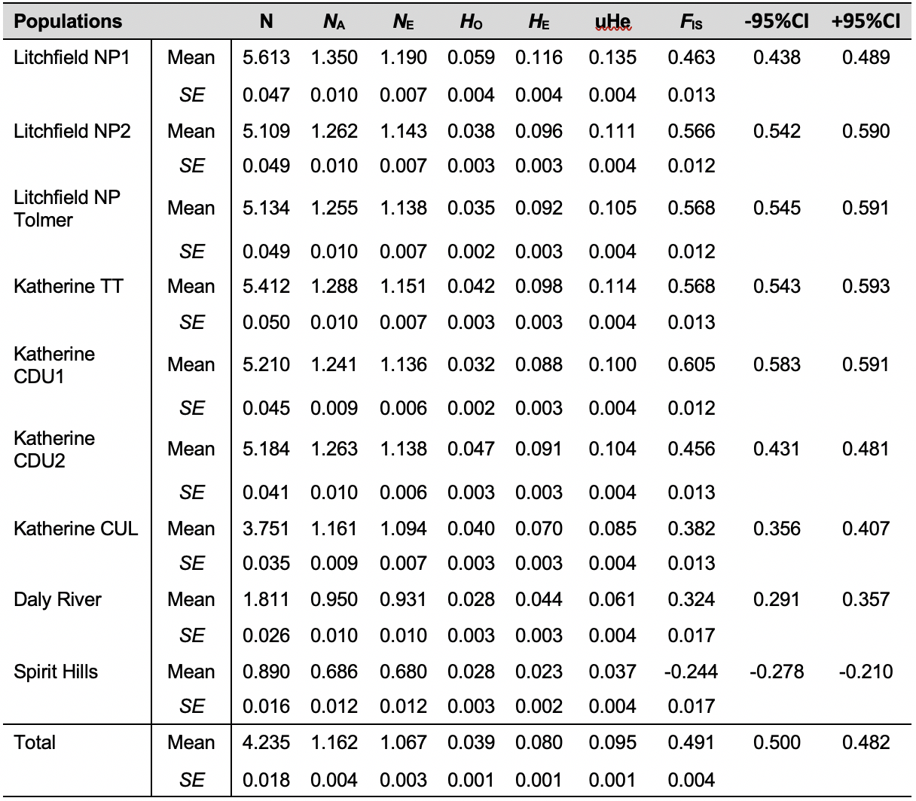

Cycas armstrongii (Table 2) gene diversity (H_{E}) ranged from 0.009 (± 0.002) for the Bathurst Island population to 0.033 (± 0.003) for the Litchfield Park Road 1 population, with a mean of 0.020 (± 0.001). The observed heterozygosity (H_{O}) ranged from 0.005 (± 0.002) in Bathurst island population to 0.057 (± 0.005) in Milikapiti 1 population, with a mean of 0.036 (± 0.001). The inbreeding coefficient (F_{IS}) ranged from 0.007 (-0.619 to -0.669 95%CI) in the Bathurst island to 0.040 (0.081 to 0.051 95%CI) in Milikapiti 1.

Table 2 Summary of population genetic statistics for populations of Cycas armstrongii. Mean and standard error (SE) of frequency-based population genetic statistics for populations of C. armstrongii within the defined IBRA7 regions, generated using GenALEx 6.5. Effective number of individuals in each population (N), effective number of alleles (N_{A}), the effective number of alleles (N_{E}), heterozygosity observed (H_{O}), heterozygosity expected (H_{E}), unbiased expected heterozygosity (uHe), and Fixation index (F_{IS}). Calculation of the fixation 95% confidence interval (mean±1.96*SE) lower (-95%CI) and upper limits (+95%CI).
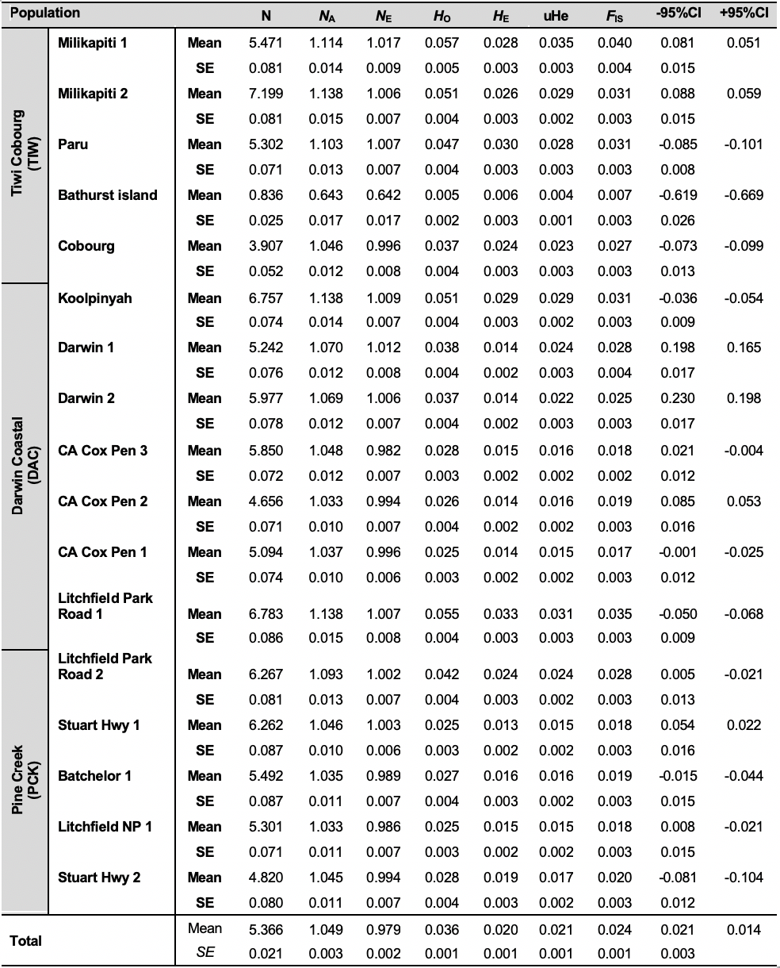

Cycas maconochiei subsp. maconochiei (Table 3) showed a gene diversity (H_{E}) that ranged from 0.043 (± 0.002) in the Cox peninsula population 3 to 0.059 (± 0.002) in the Dundee Beach 1 population, with a mean of 0.053 (± 0.001). The H_{O} ranged from 0.033 (± 0.002) in the Dundee Forest population to 0.049 (± 0.002) in the Bynoe 1 population, with a mean of 0.040 (± 0.001). The mean H_{E} (0.053 ± 0.001) and H_{o} (0.040 ± 0.001) indicate that all populations of C. maconochiei fall outside of the HWE. The inbreeding coefficient (F_{IS}) ranged from 0.037 (0.021 - 0.053 95%CI) in the Bynoe 1 population to 0.243 (0.225 to 0.262 95%CI) in the Bynoe 2 population. Cycas armstrongii x C. maconochiei (Leviathan Creek) (Table 3) had an expected heterozygosity (H_{E}) of 0.020 (± 0.002) and a H_{O} of 0.018 (± 0.002).

Table 3 Summary of population genetic statistics for populations of Cycas maconochiei subsp. maconochiei and C. armstrongii x C. maconochiei. Mean and standard error (SE) of frequency-based population genetic statistics for populations of C. maconochiei subsp. maconochiei and C. armstrongii x C. maconochiei, generated using GenALEx 6.5 in the Darwin Costal Region (DAC01). Number of individuals in each population (N), effective number of alleles (N_{A}), the effective number of alleles (N_{E}), heterozygosity observed (H_{O}), heterozygosity expected (H_{E}), unbiased expected heterozygosity (uHe), and Fixation index (F_{IS}). Calculation of the fixation 95% confidence interval (mean±1.96*SE) lower (-95%CI) and upper limits (+95%CI). Cycas armstrongii x C. maconochiei = Leviathan Creek. Calculation of the fixation 95% confidence interval (mean±1.96*SE) lower (-95%CI) and upper limits (+95%CI).
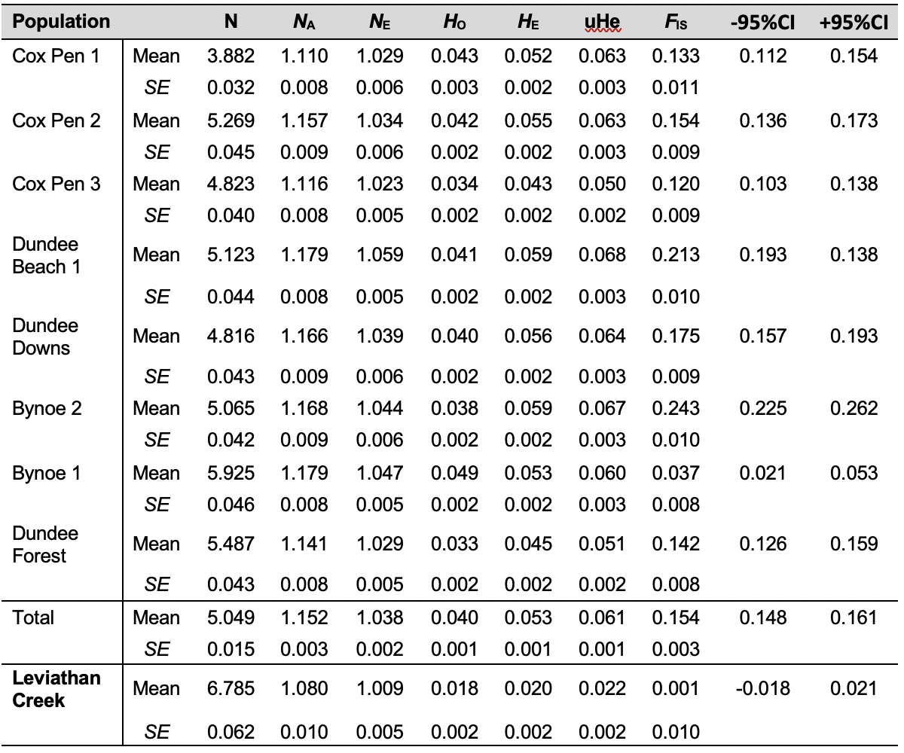

Genetic structure and population differentiation. The AMOVA results (Table 4) showed the same level of differentiation at the regional (6%) and population level (6%), with the majority of genetic variation contained within populations (89%). Despite the relatively large geographic distance between the Litchfield and Katherine regions (~250 km between regions) (Figure 4), genetic differentiation is low.
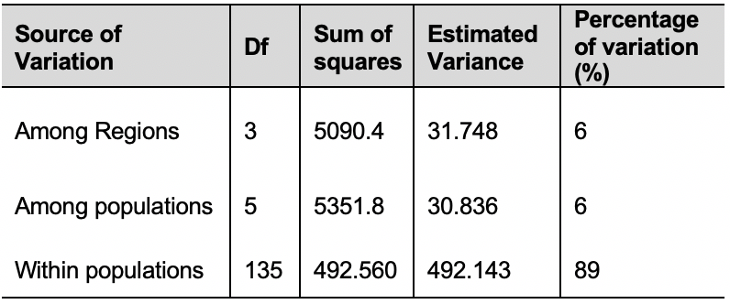
Table 4 Analysis of molecular variance for Cycas calcicola populations. Results for Analysis of Molecular Variance (AMOVA) for populations of C. calcicola. Df = Degree of Freedom, Among populations = genetic variation among the populations within the region and Within populations = degree of genetic variation within the populations in a region.

AMOVA for C. armstrongii and C. maconochiei (Table 5) showed that there was 6% genetic variation between C. armstrongii and C. maconochiei There was 14% variation among all populations, with the majority of variation (80%) contained within populations. Cycas armstrongii had 3% genetic variation among IBRA subregions, 13% genetic variation between its populations, and with the majority of the genetic variation being within populations (84%). Cycas maconochiei had no genetic variation between regions, 6% genetic variation between populations, with most genetic variation being within populations (94%).
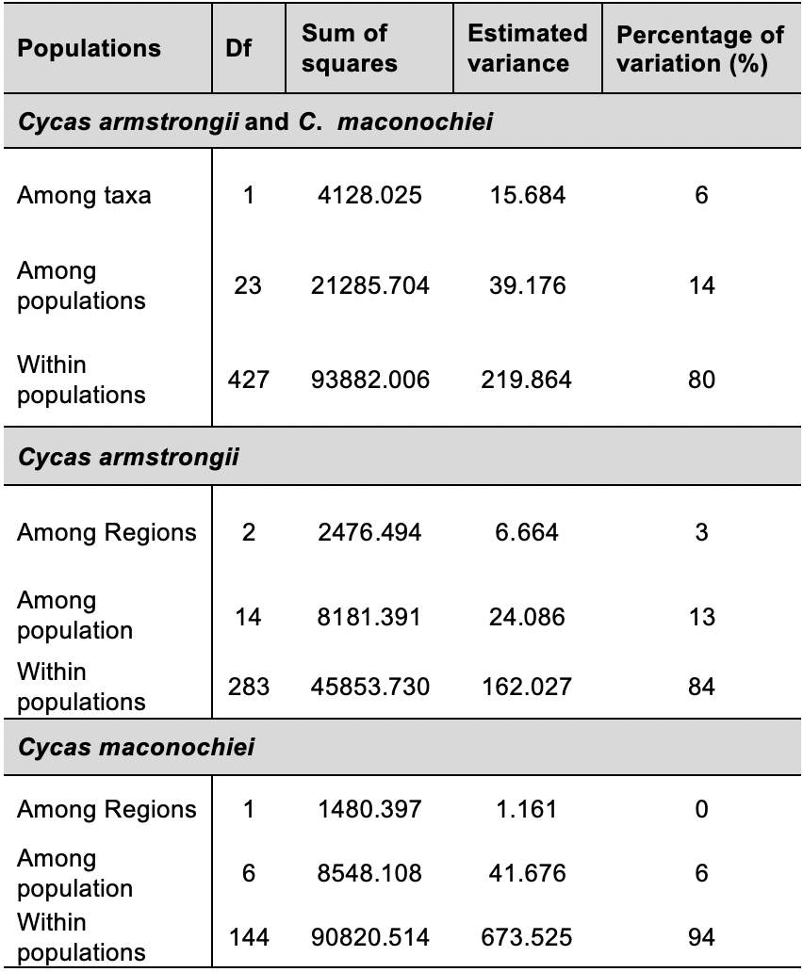
Table 5 Analysis of molecular variance for Cycas armstrongii and C. maconochiei subsp. maconochiei. Results for Analysis of Molecular Variance (AMOVA) for populations of C. armstrongii and C. maconochiei subsp. maconochiei. Df = Degree of Freedom, among populations = genetic variation among the populations within the localities and within populations = degree of genetic variation within the populations in a region.

Pairwise F_{ST} values (Table 6) for C. calcicola indicated low to medium levels of genetic distance between most populations, indicating high levels of gene flow. F_{ST} values ranged from 0.048 between Litchfield NP1 and Litchfield NP2 to 0.248 between Daly River and Spirit Hills.

Table 6 Pairwise distance based F_{ST} matrix of Cycas calcicola populations. Genetic distance based pairwise F_{ST} matrix from AMOVA analysis generated using GenALEx 6.5 for Cycas calcicola populations. Values greater ≥ 0.20 are highlighted in bold.
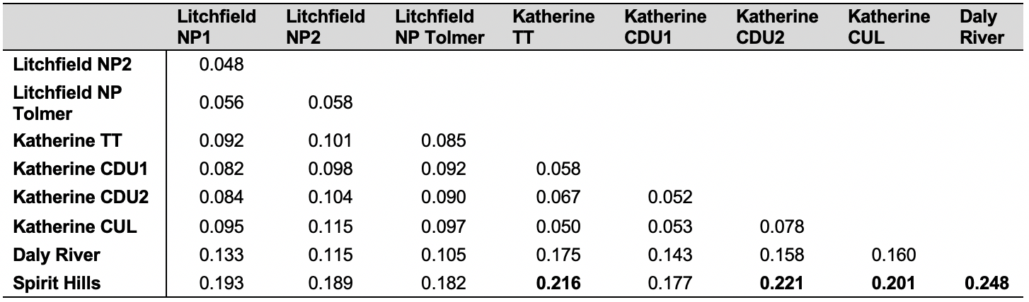

The distance based (AMOVA) pairwise fixation index (F_{ST}) were calculated for C. armstrongii and C. maconochiei subsp. maconochiei separately. The genetic distance between populations of C. armstrongii (Table 7) ranged from 0 (0%) in multiple populations especially populations within the Tiwi Corbourg regions to 0.234 (23.4%) between the Cobourg and Cox Pen 3 population. The pairwise fixation index (F_{ST}) showed genetic distance between IBRA7 sub regions (Table 8) ranged from 0.009 (0.099%) between Darwin Costal and Pine Creek to 0.127 (12.7%) between Cobourg to Pine Creek. These results indicated that populations occurring within Tiwi (TIW) showed evidence of a greater genetic distance from the Darwin Costal and Pine Creek regions (DAC/PCK), which agree somewhat with geography (Figure 1). The genetic distance between populations of C. maconochiei subsp. maconochiei (Table 9) ranged from 0.041 (4.1%) between the Dundee Forest and the Cox Pen 1 populations to 0.098 (9.8%) between Dundee Beach 1 and Bynoe 1 populations. Overall, no populations of C. maconochiei subsp. maconochiei had greater than 10% genetic distance.

Table 7 Pairwise FST matrix of Cycas armstrongii populations. Genetic distance based pairwise F_{ST} matrix from AMOVA analysis generated using diveRsity 1.9.90 for Cycas armstrongii populations within the defined Interim Biogeographic Regionalisation for Australia (IBRA7). Values greater ≥ 0.20 are highlighted in bold.
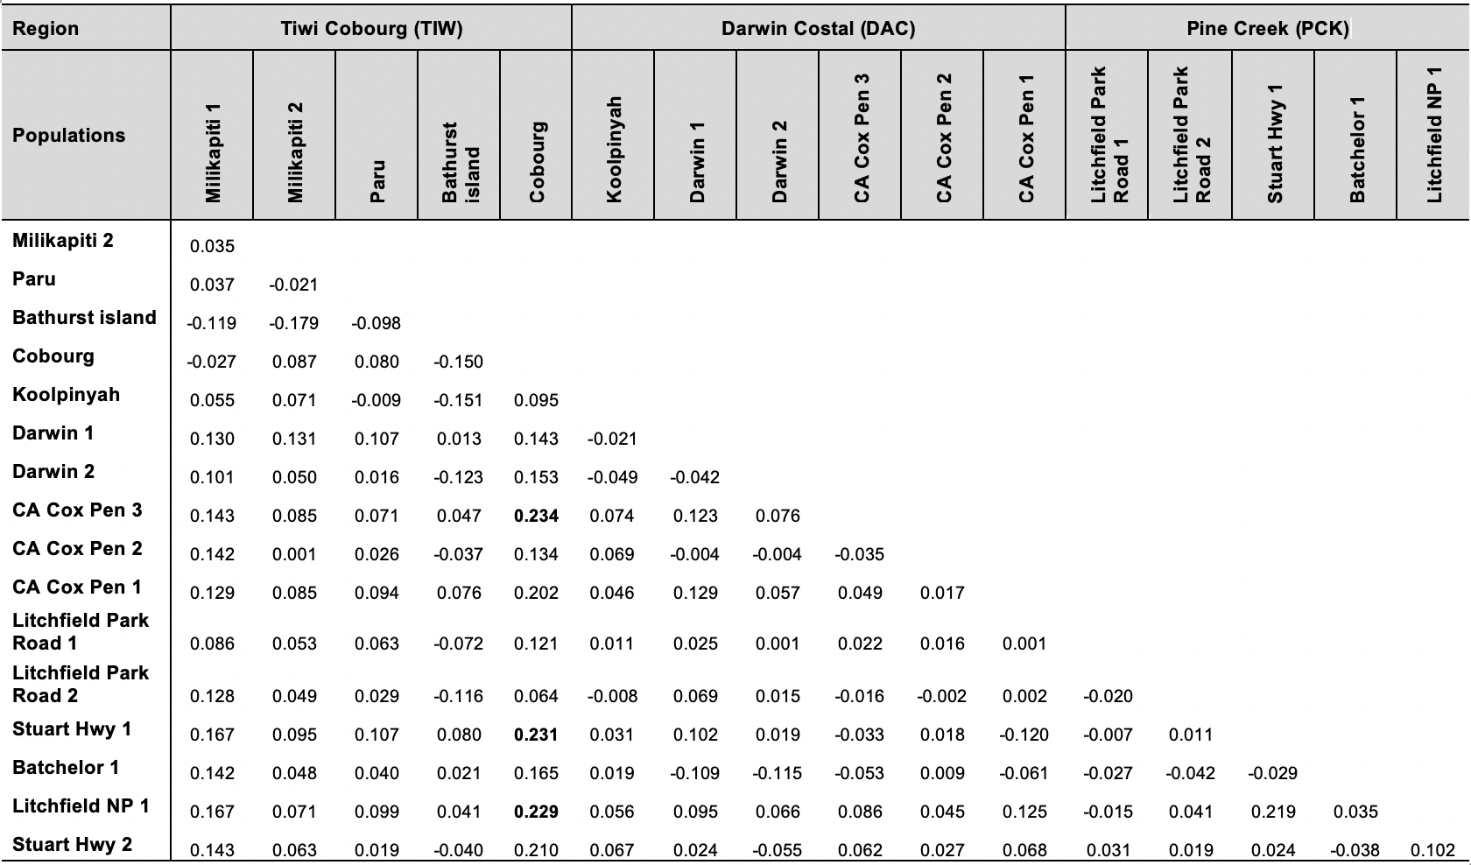
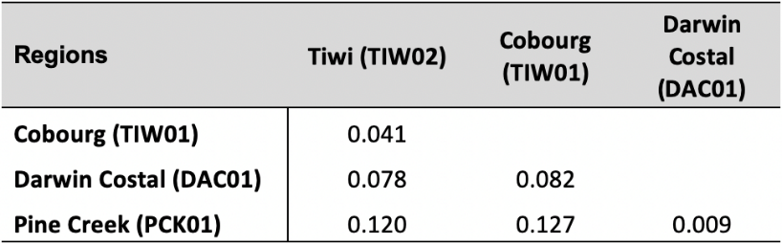
Table 8 Pairwise FST matrix between Cycas armstrongii regions. Genetic distance based pairwise F_{ST} matrix from AMOVA analysis generated using GenALEx 6.5 to show genetic distance between sub-regions for the Interim Biogeographic Regionalisation for Australia (IBRA7) of Cycas armstrongii.

Table 9 Pairwise FST matrix of Cycas maconochiei subsp. maconochiei populations. Genetic distance based pairwise F_{ST} matrix from AMOVA analysis generated using GenALEx 6.5 for Cycas maconochiei subsp. maconochiei populations in the Darwin Costal Region (DAC01).
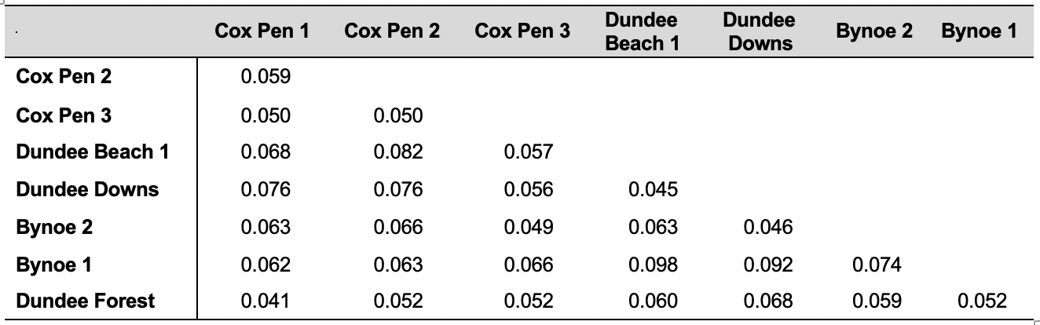

Population structure analysis. Population structure analysis found the most likely number of genetic groups to be K=2 (Figure 8). The structure plot shows genetic differentiation between populations in the Litchfield and Katherine region, with some admixture. Spirit Hills and Daly River show populations have a closer genetic relationship Litchfield than the Katherine region, with significant admixture. Overall there was less admixture in the Katherine populations than Litchfield, Spirit Hills and Daly River.
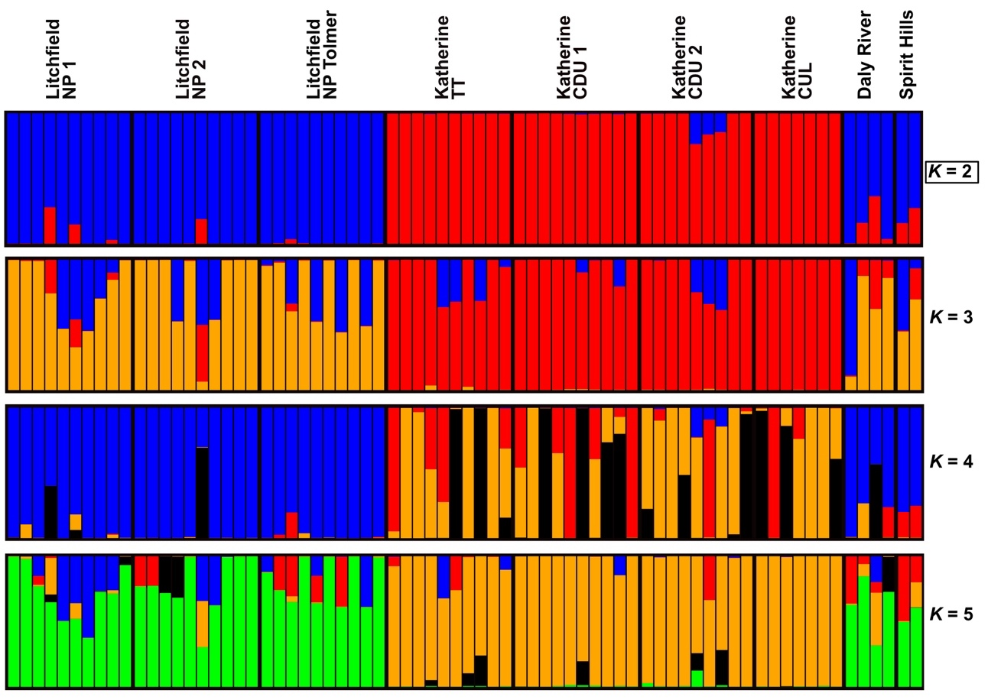
Figure 8 Population structure plot for Cycas calcicola populations. Population structure plot represents 72 samples from eight populations of C. calcicola. The most likely number of genetic groups for the species was K=2 indicating two clusters within the data.
Cycas armstrongii show no defined population structure between regions and populations (Figure 9). Cycas maconochiei subsp. maconochiei population structure analysis (Figure 10) showed the same results for Cycas armstrongii containing only a single genetic group of K = 1. The structure plot combining C. armstrongii, C. maconochiei subsp. maconochiei and C. armstrongii x maconochiei (Figure 11), showed only a single genetic group (K = 1), with no differentiation between populations, or between taxa.
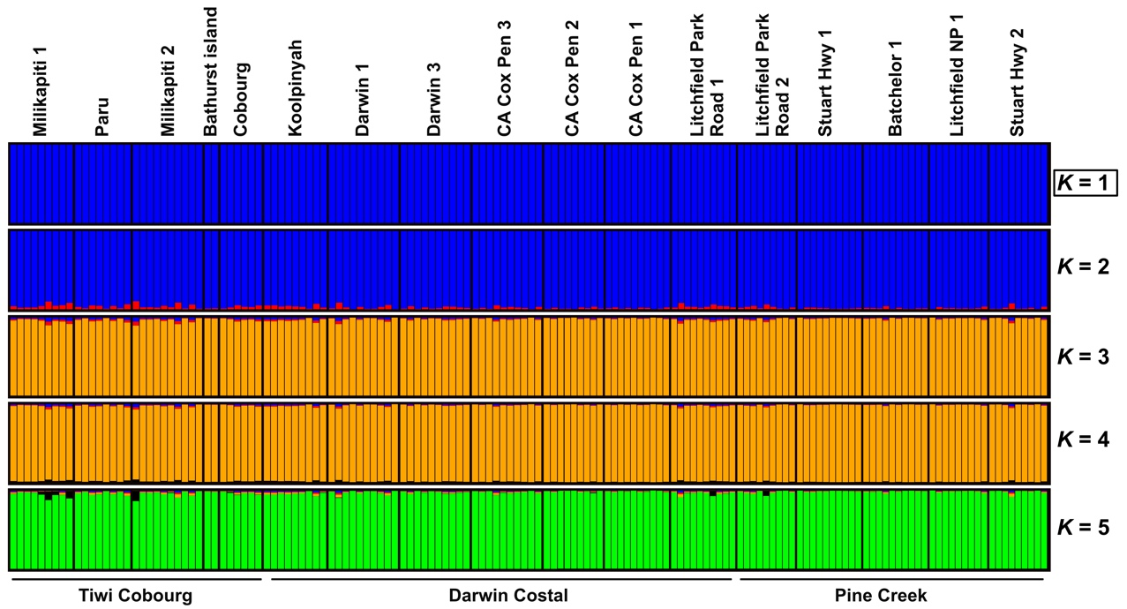
Figure 9 Population structure plot for Cycas armstrongii populations. Population structure plot represents 150 samples from 12 populations in 3 defined regions representing the Interim Biogeographic Regionalisation for Australia (IBRA7). The highest model value indicated K=1 a single genetic within the data.
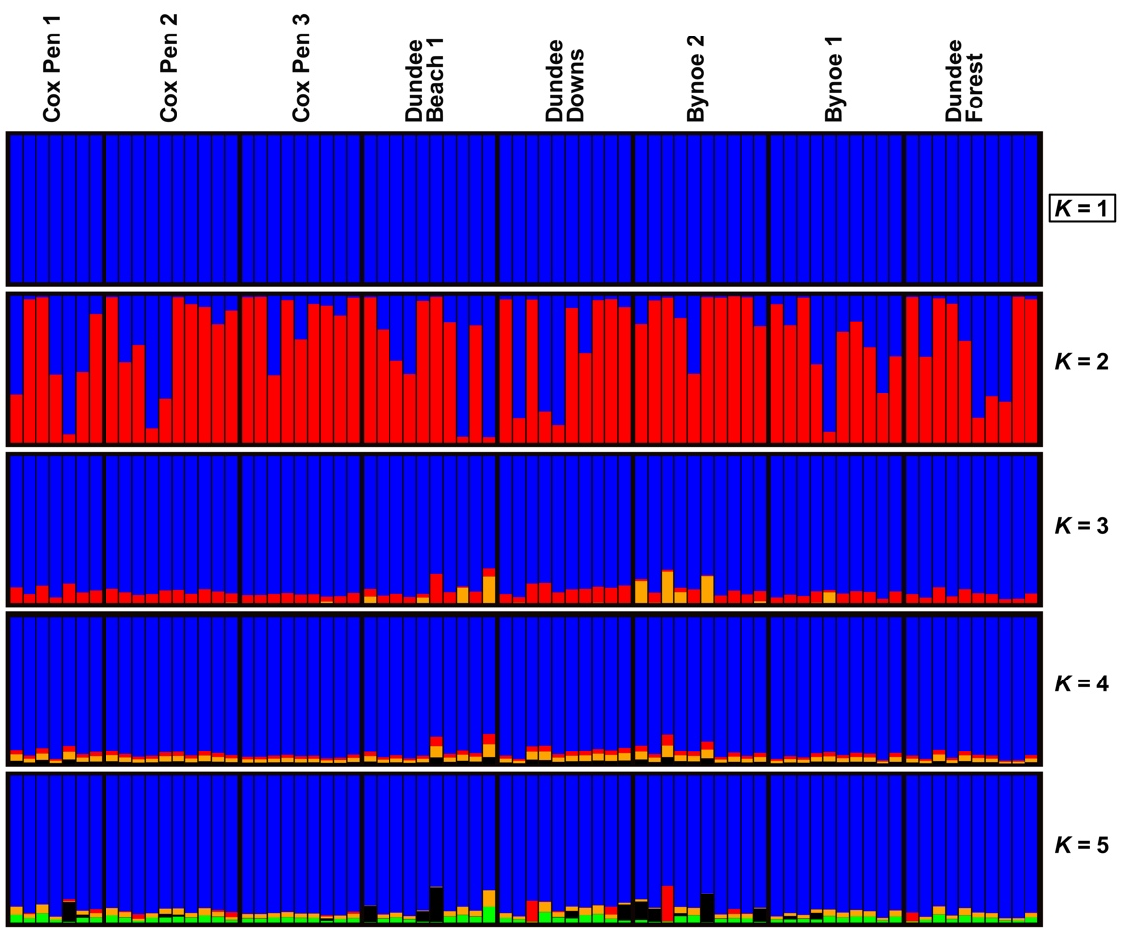
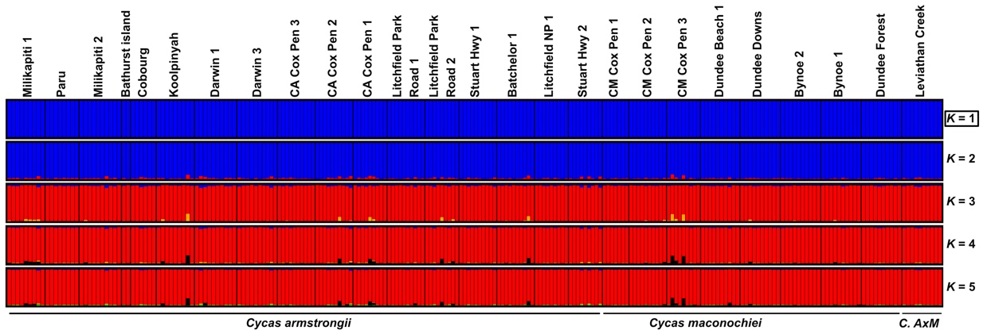
Figure 10 Population structure plot for Cycas maconochiei subsp. maconochiei populations. Population structure plot represents 77 samples from 8 populations in the IBRA7 defined Darwin Costal Region The highest model value K=1 indicating a single genetic group in the data.
Figure 11 Population structure plot for Cycas armstrongii, C. maconochiei subsp. maconochiei and Cycas armstrongii x maconochiei. Population structure plot represents 247 samples from 22 populations in 3 regions from the defined Interim Biogeographic Regionalisation for Australia (IBRA7). The highest model value K=1 indicating a single genetic group in the data.
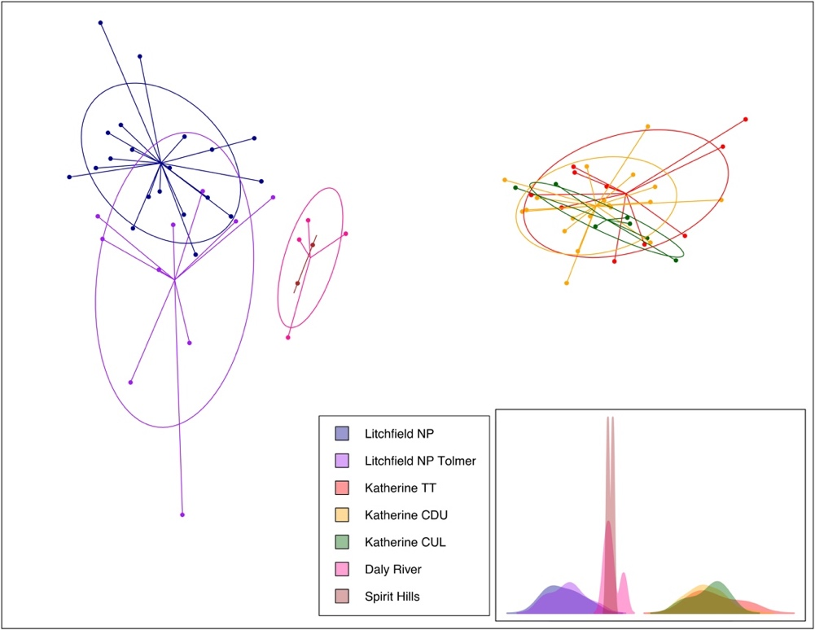
Discriminant analysis of principal components. For the discriminant analysis of principal component (DAPC) (Figure 12), 14 principal components were retained for the PCA, which comprised three genetic groups (K = 3) with a proportion of conserved variance = 0.391. These results indicate a close genetic relationship exists among populations in the Katherine and Litchfield region. However, there is evidence genetic differentiation between the Litchfield and Katherine regions. Additionally. The results show that populations occurring in Spirit Hills and Daly River are genetically closer to populations of the Litchfield region.
Figure 12 DAPC graph of Cycas calcicola populations. Discriminate analysis of principal component shows all seven populations of C. calcicola, representing both the Litchfield and Katherine regions, in the Northern Territory, Australia. DAPC is a summary of 14 PCs with three discriminate functions (K = 3) and a proportion of conserved variance of 0.391.

For Cycas armstrongii and C. maconochiei subsp. maconochiei DAPC’s were split into four analyses. The DAPC for C. armstrongii (Figure 13) was examined for IBRA subregions throughout the Darwin coastal (DAC), Pine Creek (PCK), and Tiwi Coburg (TIW) IBRA regions. The DAPC was a summary of 62 PCs from the PCA, with three genetic groups (K = 3) and a proportion of conserved variance of 0.618. Figure 16 shows little differentiation between Darwin Coastal and Pine Creek regions, indicating a close genetic connection. However, Tiwi (TIW02) and Coburg subregions (TIW01) show a higher level of genetic differentiation between both subregions and the Darwin coastal (DAC)/Pine Creek (PCK) regions.
The DAPC for Cycas maconochiei subsp. maconochiei (Figure 14) was representative of populations occurring in the Darwin coast (DAC) IBRA region, and was a summary of 31 PCs for the PCAs with two discriminant functions (K = 2) and a proportion of conserved variance of 0.619. However, the DAPC of C. maconochiei shows little differentiation between populations, indicating low levels of genetic distance among population, and potential gene flow. The DAPC of C. armstrongii, C. maconochiei subsp. maconochiei, and C. armstrongii x C. maconochiei (Figure 15) was a summary of 33 PC’s from the PCA with two discriminant functions (K = 2), and a proportion of conserved variance of 0.526 (Figure 18). Figure 18 shows very low levels of differentiation between all taxa and provides little evidence to support hybridisation.
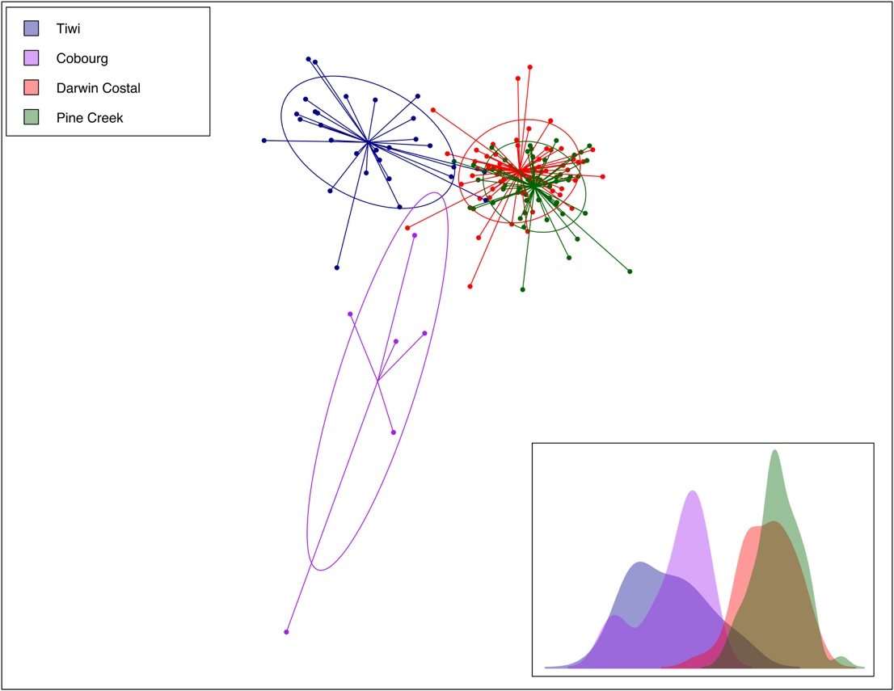
Figure 13 DAPC graph of Cycas armstrongii populations represented as IBRA subregions. Discriminate analysis of principal component (DAPC) showing genetic differentiation between Cycas armstrongii populations throughout the Darwin Costal, Pine Creek, and Tiwi Cobourg IBRA subregions in the Northern Territory Australia. DAPC is a summary of 62 PC’s for the PCA’s with three discriminant functions (K = 3) and a proportion of conserved variance of 0.618.

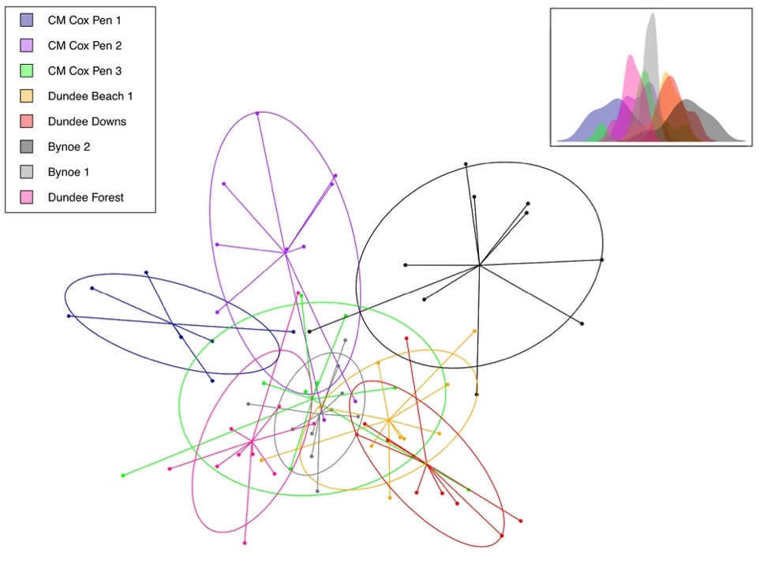
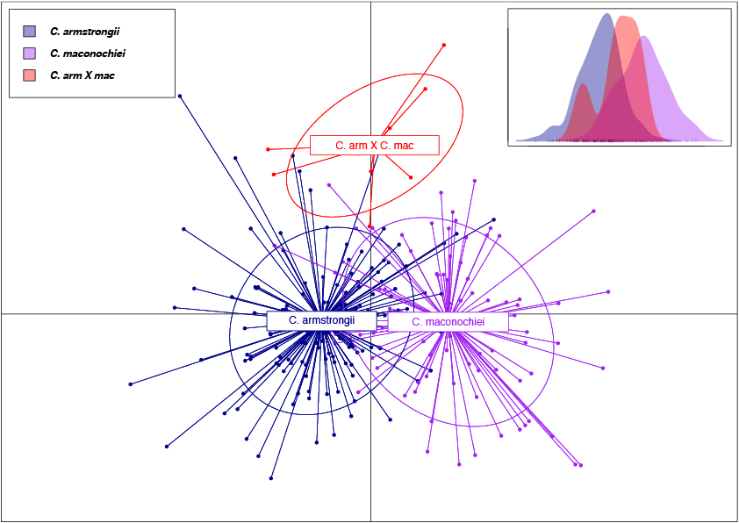
Figure 14 DAPC graph of Cycas maconochiei subsp.maconochiei grouped into populations. Discriminate analysis of principal component shows genetic differentiation between populations C. maconochiei subsp.maconochiei. The plot represents populations occurring the Darwin Costal Region, in the Northern Territory Australia. DAPC is a summary of 31 PC’s for the PCA’s with two discriminant functions (K = 2) and a proportion of conserved variance of 0.619.
Figure 15 DAPC graph of Cycas armstrongii, C. maconochiei subsp.maconochiei and Cycas armstrongii x maconochiei population group by taxon. Discriminate analysis of principal component shows genetic differentiation between two species Cycas armstrongii and C. maconochiei subsp.maconochiei and a single hybrid population C. armstrongii x maconochiei. The plot represents all populations throughout the Darwin and greater region, in the Northern Territory Australia. DAPC is a summary of 33 PC’s for the PCA’s with two discriminant functions and a proportion of conserved variance of 0.526.
Discussion
This study presents a case for exploring new techniques and developing new approaches, which can be applied to the population genetics of cycads and other organisms with large and complex genomes. By using RADseq we have provided important insights into the genetic history and diversity of the genus Cycas in Australia. RADseq offers the ability to multiplex and sequence many individuals simultaneously, at relatively low cost. Using RADseq we were able to recover up to 3043 genome wide SNPs for at least 50% of the samples per locus.
While this study focused on selected Australian taxa, the techniques presented here are applicable to all cycad genera. The markers generated have the potential to be effective for both population level and phylogenetic studies (Catchen et al. 2017; Tripp et al. 2017; McKinney et al. 2016; Davey & Blaxter 2010). Here we have demonstrated that RADseq can be applied to organisms with large genomes such as cycads, and we have developed a protocol for others to follow. Ultimately, the methodology presented here will help to resolve the relationships among cycads and to help gain deeper insights into the genetic diversity among Cycadales species. This data and relevant techniques are directly applicable when developing informed conservation management plans for cycads and other groups of seed plants.
The research presented here focused on three taxa - Cycas armstrongii, C. calcicola and C. maconochiei subsp. maconochiei and a single suspected hybrid population Cycas armstrongii x C. maconochiei (Figures 1, 2 and 3). In C. calcicola the populations are small and geographically disjunct (Figure 4) but have a wide distribution with low levels of genetic diversity and low differentiation between populations (Tables 5 and 6). However, despite the low levels of differentiation between populations, there was evidence of genetic differences between the Lichfield and Katherine regions which correlates with geographic distances (Figures 8 and 12). This indicates that the spatial arrangement of C. calcicola populations may be recent. We also found high inbreeding in some populations, which could result in lower adaptive potential of the species (Table 1). This, in turn, raised concerns for the conservation of species in the face of rapid global climate change and anthropogenic threats to habitats (De La Torre et al. 2019).
In order to mitigate the conservation concerns, we determined if ex-situ conservation collections in botanic gardens represented the genetic diversity of the wild populations (Griffith et al. 2015). Our results showed that populations of C. calcicola from the Litchfield National Park were currently not represented in well managed and curated ex-situ collections, yet they do occur in National Parks and are afforded some degree of protection. Regardless of the current levels of protection for some populations this species, we were able to identify that a considerable amount of genetic diversity of the species is not represented in ex-situ collections. As a result of these factors we feel the best approach towards conserving C. calcicola is to conserve each population from the Litchfield National Park and Katherine regions as separate conservation management units.

Advocating representative ex-situ collection of cycads for the purpose of conservation presents a series of problems that our approach to population genetics might assist with (Hurka 1994). In particular, our techniques provide insights into what type of material, and how much of it, should be collected in order to represent the optimal genetic diversity of a taxon (Clugston et al. 2019). The simplest solution would be to collect seed from wild populations, yet while seed production by most cycads is relatively high (~160 viable seeds from a single female strobilus), the number of seeds produced in each season is limited by the number of females and males simultaneously coning in a reproductive event (Ballardie et al. 1986). Seed recruitment in populations of Australian cycads can also be significantly reduced by increased burning frequencies (Hall et al. 2013; Liddle 2009; Ornduff 1991). We have also shown that interpopulational seed dispersal (i.e. migration) in Australia cycads is rare. Thus, the targeted removal of seeds for ex-situ conservation from small populations with low genetic diversity could place further stress upon the long-term survival of some Australian Cycas species (Andersen 1989).

Populations of Cycas armstrongii and C. maconochiei subsp. maconochiei showed very low levels of allelic diversity and differentiation across the populations with some evidence of inbreeding (Tables 2, 3 and 5). Furthermore, low levels of genetic differentiation between the two taxa were observed (Figures 15). These results indicated that C. armstrongii and C. maconochiei subsp. maconochiei might represent a single, morphologically diverse species with a wide distribution across the lower latitudes of Northern Territory (Figures 9, 10, 11 and 15). By extension, our results did not recover any support for the formal recognition of the interspecific hybrid, Cycas armstrongii x C. maconochiei. Ideally, before formal taxonomic proposal can be put forward this study needs to be expanded to include samples C. maconochiei subsp. viridis which is found in a remote area west of the study area. Thus, we conclusively demonstrated that RADseq protocols are sensitive enough to enable similar species relationship (and putative hybrids) to be assessed independently of morphological hypotheses, using genomewide markers (Clugston et al. 2019). However, although studies like our own which used next generation sequencing on cycads have provided a significantly greater number of markers, the resulting genetic statistics have found no greater diversity in cycads in Australia, likely due to historic factors (Sharma et al. 2004; Sharma et al. 1999). Of course, this does not mean that techniques such as RADseq are ineffective on groups like cycads – in fact they are the best option available and have the most potential for uncovering the evolutionary history of the group (Clugston et al. 2019).

The genetic patterns of C. armstrongii and C. maconochiei subsp. maconochiei, as revealed by our use of RADseq techniques, provided us with an opportunity to investigate the process that had led to the current genetic architecture and the spatial arrangement of populations. We concluded that the contemporary populations represent relictual populations derived from much larger ancestral populations (Laidlaw & Forster 2012). The fragmentary distribution of contemporary cycads in the Northern Territory of Australia and range retraction could also be a result of the extension of their primary, megafaunal seed dispersal (Hall and Walter 2013). The demise of seed vectors would mean that geographic range extension, and migration between populations, would be significantly curtailed. In turn, the resultant small population sizes and restricted geographic distribution, combined with slow rates of reproduction, could explain the reduction in allelic diversity found in C. armstrongii, C. calcicola, and C. maconochiei subsp. maconochiei.

It is conceivable that species of Cycas in the Northern territory of Australia could have diversified recently and rapidly (Crisp & Cook 2011; Nagalingum et al. 2011). In particular, the evidence presented by Crisp & Cook (2011) shows that not only cycads have been subjected to multiple extinction and radiation events but also other members of the gymnosperms, which could have accounted for the low levels of genetic diversity in many species, given selective pressures acting on cycad populations (Donaldson 2003). In the case of cycads growing in the Northern Territory of Australia as studied here, warmer, drier periods are likely to cause a range restrictions, whereas cooler drier periods with reduced sea level (e.g. glacial maxima) offer greatly increased habitat areas, with dispersal across land bridges (Preece et al. 2007), allowing periodic mixing of populations (Erwin 2009).

Rapid divergence of closely related plant lineages does not always keep pace with the evolution of breeding barriers, due to a range of biotic and abiotic factors such as pollinators and habitats (Rieseberg and Willis 2007). Additionally, factors such as changes in cone production times and self-fertilisation as a result of mutation can have a significant effect of the genetic variance of population (Macnair 1989). In such cases, demographic barriers serve as isolating mechanisms between closely related taxa. When the demographic barriers are relaxed (Widmer et al. 2009), populations of otherwise segregated lineages become parapatric or sympatric, thereby increasing the likelihood for gene flow between the closely related lineages. Because the effects of habitat fragmentation isolates populations and reduces population size, which can cause genetic erosion and inbreeding, which affects the reproductive potential of a population (Honnay 2002). Although even minor levels of gene flow among populations can help spread advantageous alleles, and can counteract the effects of genetic erosion (Morjan and Rieseberg 2004). Yet for our study taxa although the low interpopulational differentiation, which indicates significant geneflow between populations which are geographically. This means that the isolation is perhaps due to recent fragmentation and exacerbated by poor seed dispersal, which has not left a genetic fingerprint, perhaps due to anthropogenic causes (Leblois et al. 2006). These results demonstrate importance in understanding the demographic history of species with both small and large populations and is a key factor in determining the extinction potential of a species (Oostermeijer et al. 2003).

If the reproductive barriers are not fixed in plants such as cycads, then closely related lineages (species) can hybridise to produce seemingly novel morphological intermediates (Baack et al. 2015). Cycads display this phenomenon repeatedly, which is not consistent with the traditional view of cycads as a slow evolving and ancient group of organisms. The results presented by this study presents evidence from other cycads species with low levels of genetic diversity that may be threatened by extinction. In particular, populations of C. calcicola are likely to become more isolated and show lower levels of genetic diversity. This does not look favourable for the genetic fitness of populations and could have a direct effect on the future adaption of species (Mankga & Yessoufou 2017). However, both C. armstrongii and C. maconochiei subsp. maconochiei showed similar patterns found in C. calcicola despite having larger populations, indicating a trend for lower genetic diversity of cycads in Australia.

Our work demonstrates despite the rapid and recent diversification of cycads (Nagalingum et al. 2011), RADseq provides a valuable approach to understand the genetic diversity of taxa with large genomes, and used to aid in the conservation of species (Leitch & Leitch 2013) and for investigating similar cases across the cycads despite their very large and complex genomes. As for the future of cycad conservation and survival of the species, well-informed botanic gardens with excellent genetic representation in well-curated collections will play a fundamental role when combined with well-informed conservation management plans in conserving genetic diversity of the species (Griffith et al. 2015). Ultimately, this study presents an excellent case for the application of RADseq not only in cycads, but also for other organisms with large and complex genomes (Clugston et al. 2019).

Acknowledgements
We wish to acknowledge funding received from the Australian Flora Foundation, the Australasian Systematic Botany Society’s and The Nature Conservatory - The Thomas Foundation for an Australian Conservation Taxonomy Award. Furthermore, we wish to acknowledge the Biotechnology and Biological Sciences Research Council (BBSRC), UK for the EASTBIO Doctoral Training Partnership in providing a studentship at the University of Edinburgh.
We also thank staff at the Royal Botanic Gardens and Domain Trust, in particular, Carolyn Connolly is thanked her support in the molecular laboratory, Hannah McPherson for helping in the initial quality testing of data, and Maureen Phelan and Simon Goodwin for assistance obtaining DNA samples from the living collections. We also thank the various botanic gardens for providing C. calcicola leaf samples. At the Royal Botanic Garden Edinburgh, we wish to thank Markus Rusham for his support in assessing the project and providing vital input into population genetics.

References
Aguilar, R. et al., 2019. Habitat fragmentation reduces plant progeny quality: a global synthesis. J. M. Gomez, ed. Ecology letters, 22(7), pp.1163–1173.
Ahrens, C.W. et al., 2017. Genomic diversity guides conservation strategies among rare terrestrial orchid species when taxonomy remains uncertain. Annals of Botany, 119(8), pp.1267–1277.
Amos, W. & Balmford, A., 2001. When does conservation genetics matter? Heredity, 87(3), pp.257–265.
Andrews, K.R. et al., 2016. Harnessing the power of RADseq for ecological and evolutionary genomics. Nature Reviews. Genetics, 17(2), pp.81–92.
Andrews, K.R. et al., 2014. Trade-offs and utility of alternative RADseq methods: Reply to Puritz et al. Molecular Ecology, 23(24), pp.5943–5946.
Bolger, A.M., Lohse, M. & Usadel, B., 2014. Trimmomatic: a flexible trimmer for Illumina sequence data. Bioinformatics, 30(15), pp.2114–2120.
Cabrera-Toledo, D. et al., 2010. Allozyme diversity levels in two congeneric Dioon spp. (Zamiaceae, Cycadales) with contrasting rarities. Plant Systematics & Evolution, 290(1-4), pp.115–125.
Cabrera-Toledo, D., González-Astorga, J. & Flores-Vázquez, J.C., 2012. Fine-scale spatial genetic structure in two Mexican cycad species Dioon caputoi and Dioon merolae (Zamiaceae, Cycadales): Implications for conservation. Biochemical Systematics & Ecology, 40, pp.43–48.
Calonje M, Stevenson DW, Stanberg L. The World List of Cycads, online edition [Internet]. 2013-2019. [cited 2018 Jul 21]. Available from: http://www.cycadlist.org.
Calonje, M., Meerow, A.W., Knowles, L., Knowles D., 2013. Cycad biodiversity in the Bahamas Archipelago and conservation genetics of the threatened Zamia lucayana (Zamiaceae). Oryx, 47(2), pp.190–198.

Calonje, M., Kay, J. & Griffith, P.M., 2011. Propagation of Cycad Collections from Seed: Applied Reproductive Biology for Conservation. Sibbaldia: the Journal of Botanic Garden Horticulture, 9, pp.77–96.
Cantrill, D. J. 2018. The Australasian Virtual Herbarium: Tracking data usage and benefits for biological collections. Applications in plant sciences, 6(2), e1026. Available at: https://avh.chah.org.au (accessed 12th January 2015).
Charlesworth, D. & Willis, J.H., 2009. The genetics of inbreeding depression. Nature Reviews. Genetics, 10(11), pp.783–796.
Charlesworth, D. 2003. Effects of inbreeding on the genetic diversity of populations. Philosophical Transactions of the Royal Society of London. Series B: Biological Sciences, 358(1434), 1051-1070.
Chen, C., Mitchell, S. E., Elshire, R. J., Buckler, E. S., & El-Kassaby, Y. A. 2013. Mining conifers’ mega-genome using rapid and efficient multiplexed high-throughput genotyping-by-sequencing (GBS) SNP discovery platform. Tree Genetics & Genomes, 9(6), 1537-1544.
Chen, S. Y., Zhang, Y. J., Wang, X. L., Sun, J. Y., Xue, Y., Zhang, P., & Qu, L. H. 2012. Extremely low genetic diversity indicating the endangered status of Ranodon sibiricus (Amphibia: Caudata) and implications for phylogeography. PLoS One, 7(3), e33378.
Cibrian-Jaramillo, A. et al., 2013. What is the conservation value of a plant in a botanic garden? Using indicators to improve management of ex situ collections. The Botanical Review, 79(4), 559-577.
Cibrián-Jaramillo, A. et al., 2010. When North and South don’t mix: genetic connectivity of a recently endangered oceanic cycad, Cycas micronesica, in Guam using EST-microsatellites. Molecular Ecology, 19(12), pp.2364–2379.
Clark, D.A. & Clark, D.B., 1987. Temporal and environmental patterns of reproduction in Zamia skinneri, a tropical rain forest in cycad. Journal of Ecology, 75(1), p.135.
Clugston, J. A. R., Milne, R. R., Kenicer, G. J., Overcast I., Wilson, T. C., Nagalingum, N. S. 2019. RADseq as a valuable tool for plants with large genomes—a case study in cycads. Molecular Ecology Resources. 19, 1610-1622.
Coates, D.J. & Atkins, K.A., 2001. Priority setting and the conservation of Western Australia's diverse and highly endemic flora. Biological conservation, 97(2), pp.251–263.
Cohen, J.I. et al., 1991. Ex Situ Conservation of Plant Genetic Resources: Global Development and Environmental Concerns. Science, 253(5022), pp.866–872.
Crisp, M.D. & Cook, L.G., 2011. Cenozoic extinctions account for the low diversity of extant gymnosperms compared with angiosperms. The New Phytologist, 192(4), pp.997–1009.
De La Torre, A. R., Wilhite, B., & Neale, D. B. (2019). Environmental genome-wide association reveal climate adaptation is shaped by subtle to moderate allele frequency shifts in loblolly pine. Genome biology and evolution. 11(10), 2976-2989.
da Silva Carvalho, C. et al., 2015. Contemporary and historic factors influence differently genetic differentiation and diversity in a tropical palm. Heredity, 115(3), pp.216–224.
Da Silva, J.M. et al., 2012. Population genetics and conservation of critically small cycad populations: a case study of the Albany Cycad, Encephalartos latifrons (Lehmann). Biological Journal of the Linnean Society, 105(2), pp.293–308.
Dehgan, B., & Yuen, C. K. K. H. (1983). Seed morphology in relation to dispersal, evolution, and propagation of Cycas L. Botanical Gazette, 144(3), 412-418.
de Vere, N. et al., 2009. Population size and habitat quality affect genetic diversity and fitness in the clonal herb Cirsium dissectum. Oecologia, 159(1), pp.59–68.
Donaldson, J.S., 2003. Cycads: status survey and conservation action plan, IUCN-- the World Conservation Union.
Dosmann, M.S., 2006. Research in the Garden: Averting the Collections Crisis. The Botanical Review, 72(3), pp.207–234.
Drury, C. et al., 2017. Genomic patterns in Acropora cervicornis show extensive population structure and variable genetic diversity. Ecology and evolution, 7(16), pp.6188–6200.
Eaton, D.A.R. and Overcast, I.A. 2019. ipyrad: interactive assembly and analysis of RADseq data sets. macOS and Linux. Available at: http://ipyrad.readthedocs.io.
Edwards, R.D. et al., 2017. Congruent biogeographical disjunctions at a continent- wide scale: Quantifying and clarifying the role of biogeographic barriers in the Australian tropics. PLoS ONE, 12(4), pp.1–17.
Ekué, M.R.M. et al., 2008. Population genetics of the cycad Encephalartos barteri subsp. barteri (Zamiaceae) in Benin with notes on leaflet morphology and implications for conservation. Belgian Journal of Botany, 141(1), pp.78–94.
Ellstrand, N.C., 1993. Population Genetic Consequences of Small Population Size: Implications for Plant Conservation. Annual review of ecology and systematics, 24(1), pp.217–242.
Ellstrand, N.C., Ornduff, R. & Clegg, J.M., 1990. Genetic Structure of the Australian Cycad, Macrozamia Communis (Zamiaceae). American Journal of Botany, 77(5), 677-681.
Fant, J.B. et al., 2016. What to do when we cant bank on seeds: What botanic gardens can learn from the zoo community about conserving plants in living collections. American Journal of Botany, 103(9), pp.1541–1543.
Fay, M.F., 2018. Orchid conservation: how can we meet the challenges in the twenty-first century? Botanical studies, 59(1), p.16.
Feng, X., Wang, Y. & Gong, X., 2014. Genetic diversity, genetic structure and demographic history of Cycas simplicipinna (Cycadaceae) assessed by DNA sequences and SSR markers. BMC Plant Biology, 14(1), pp.187–187.
Finlay, C.M.V. et al., 2017. Low genetic diversity and potential inbreeding in an isolated population of alder buckthorn (Frangula alnus) following a founder effect. Scientific reports, 7(1), p.3010.
Fischer, M., Hock, M. & Paschke, M., 2003. Low genetic variation reduces cross-compatibility and offspring fitness in populations of a narrow endemic plant with a self-incompatibility system. Conservation Genetics, 4(3), pp.325–336.
Frankham, R., 2003. Genetics and conservation biology. Comptes Rendus Biologies, 326, Supplement 1(0), pp.22–29.
Frankham, R., Ballou, J.D. & Briscoe, D.A., 2004. A primer of conservation genetics., Comptes Rendus Biologies, 326, Supplement 1(0), pp.22–29.
Furlan, E. et al., 2012. Small population size and extremely low levels of genetic diversity in island populations of the platypus, Ornithorhynchus anatinus. Ecology and Evolution, 2(4), pp.844–857.
Gong, Y.-Q. et al., 2015. The Historical Demography and Genetic Variation of the Endangered Cycas multipinnata (Cycadaceae) in the Red River Region, Examined by Chloroplast DNA Sequences and Microsatellite Markers R. Papa, ed. PLoS ONE, 10(2), pp.1–18.
González-Astorga, J., Vergara-Silva, F., et al., 2008. Diversity and genetic structure of three species of Dioon Lindl. (Zamiaceae, Cycadales) from the Pacific seaboard of Mexico. Biological Journal of the Linnean Society, 94(4), pp.765– 776.
González-Astorga, J., Vovides, A.P., et al., 2008. Diversity and genetic structure of the endangered cycad Dioon sonorense (Zamiaceae) from Sonora, Mexico: Evolutionary and conservation implications. Biochemical Systematics and Ecology, 36(12), pp.891–899.
Griffith, M.P. et al., 2015. Can a Botanic Garden Cycad Collection Capture the Genetic Diversity in a Wild Population? International Journal of Plant Sciences, 176(1), pp.1–10.
Griffith, M.P., Magellan, T.M. & Tomlinson, P.B., 2014. Variation in Leaflet Structure in Cycas (Cycadales: Cycadaceae): Does Anatomy Follow Phylogeny and Geography? International Journal of Plant Sciences, 175(2), pp.241–255.
Griffiths, K.E. et al., 2014. Maximizing the phylogenetic diversity of seed banks. Conservation Biology, 29(2), pp.370–381.
Griffith, M. P., Calonje, M. A., Stevenson, D. W., Husby, C. E., & Little, D. P. 2012. Time, place, and relationships: cycad phenology in a phylogenetic and biogeographic context. Memoirs of the New York Botanical Garden, 106, 59-81.
Hall, J.A. & Walter, G.H., 2014. Relative Seed and Fruit Toxicity of the Australian Cycads Macrozamia miquelii and Cycas ophiolitica: Further Evidence for a Megafaunal Seed Dispersal Syndrome in Cycads, and Its Possible Antiquity. Journal of Chemical Ecology, 40(8), pp.860–868.
Hall, P., Walker, S., & Bawa, K. 1996. Effect of forest fragmentation on genetic diversity and mating system in a tropical tree, Pithecellobium elegans. Conservation Biology, 10(3), 757-768.
Hall, W.T. & McGavin, M.D., 1968. Clinical and neuropathological changes in cattle eating the leaves of Macrozamia lucida or Bowenia serrulata (Family Zamiaceae). Pathologia veterinaria, 5(1), pp.26–34.
Hamilton, M.B., 1994. Ex Situ Conservation of Wild Plant Species: Time to Reassess the Genetic Assumptions and Implications of Seed Banks. Conservation Biology, 8(1), pp.39–49.
Hedrick, P.W. & Miller, P.S., 1992. Conservation Genetics: Techniques and Fundamentals. Ecological Applications, 2(1), pp.30–46.
Hefley, T.J. et al., 2016. When can the cause of a population decline be determined? Ecology letters, 19(11), pp.1353–1362.
Hill, K.D., 1996. A taxonomic revision of the genus Cycas (Cycadaceae) in Australia. Telopea, 7(1), pp.1–64.
Hill, K.D., 1994. The Cycas rumphii complex (Cycadaceae) in New Guinea and the western Pacific. Australian Systematic Botany, 7(6), pp.543–567.
Hughes, A. R., Inouye, B. D., Johnson, M. T., Underwood, N., & Vellend, M. 2008. Ecological consequences of genetic diversity. Ecology letters, 11(6), 609-623.
Hou, L. et al., 2018. Genetic Evaluation of Natural Populations of the Endangered Conifer Thuja koraiensis Using Microsatellite Markers by Restriction-Associated DNA Sequencing. Genes, 9(4), p.218.
Huang, S. et al., 2004. Patterns of Genetic Variation and Demography of Cycas taitungensis in Taiwan. The Botanical Review, 70(1), 86-92.
Hurka, H., 1994. Conservation genetics and the role of botanical gardens. In Conservation Genetics. Basel: Birkhäuser Basel, pp. 371–380
James, H.E. et al., 2018. Conservation genetics and demographic analysis of the endangered cycad species Cycas megacarpa and the impacts of past habitat fragmentation. Australian Journal of Botany, 66(2), p.173.
Jones, D.L., 2002. Cycads of the world 2nd ed., Washington, D.C.: Smithsonian Institution Press.
Keppel, G., Hodgskiss, P.D. & Plunkett, G.M., 2008. Cycads in the insular South- west Pacific: dispersal or vicariance? Journal of Biogeography, 35(6), pp.1004– 1015.
Keppel, G., 2002. Low genetic variation in a Pacific cycad: conservation concerns for Cycas seemannii (Cycadaceae). Oryx, 36(01), pp.41–49.
Kono, M. & Tobe, H., 2007. Is Cycas revoluta (Cycadaceae) Wind- or Insect-Pollinated? American Journal of Botany (5), p.847.
Kramer, A.T. & Havens, K., 2009. Plant conservation genetics in a changing world. Trends in Plant Science, 14(11), pp.599–607.
Liddle, D.R., 2009. Management Program for Cycads in the Northern Territory of Australia. Northern Territory Department of Natural Resources, Environment, the Arts and Sport, Darwin.
Long-Qian, X. & Xun, G., 2006. Genetic differentiation and relationships of populations in the Cycas balansae complex (Cycadaceae) and its conservation complications. Annals of Botany, 97(5), pp.807–812.
Long-Qian, X. et al., 2004. ISSR Variation in the Endemic and Endangered Plant Cycas guizhouensis (Cycadaceae). Annals of Botany, 94(1), pp.133–138.
Lönn, M. & Prentice, H.C., 2002. Gene diversity and demographic turnover in central and peripheral populations of the perennial herb Gypsophila fastigiata. Oikos, 99(3), pp.489–498
Lowe, P.R., 2008. Species and Subspecies. Ibis, 64(1), pp.179–185.
Manel, S., Schwartz, M. K., Luikart, G., & Taberlet, P. 2003. Landscape genetics: combining landscape ecology and population genetics. Trends in Ecology & Evolution, 18(4), 189-197.
Meerow, A.W. & Nakamura, K., 2007. Ten microsatellite loci from Zamia integrifolia (Zamiaceae). Molecular Ecology Notes, 7(5), pp.824–826.
Meerow, A.W. et al., 2012. Zamia (Cycadales: Zamiaceae) on Puerto Rico: asymmetric genetic differentiation and the hypothesis of multiple introductions. American Journal of Botany, 99(11), pp.1828–1839.
Mondoni, A. et al., 2011. Seeds of alpine plants are short lived: implications for long- term conservation. Annals of Botany, 107(1), pp.171–179.
Muriira, N.G. et al., 2018. Genetic Diversity Analysis Reveals Genetic Differentiation and Strong Population Structure in Calotropis Plants. Scientific reports, 8(1), p.7832.
Nadarajan, J. et al., 2018. Comparative Biology of Cycad Pollen, Seed and Tissue - A Plant Conservation Perspective. The Botanical Review, 34(11), pp.20–20.
Nagalingum, N.S., Marshall, C.R., Quental, T.B., Rai, H.S., Little, D.P. and Mathews, S. 2011. Recent synchronous radiation of a living fossil. Science, 334(6057), pp. 796–799.
Namroud, M. C., Beaulieu, J., Juge, N., Laroche, J., & Bousquet, J. 2008. Scanning the genome for gene single nucleotide polymorphisms involved in adaptive population differentiation in white spruce. Molecular Ecology, 17(16), 3599-3613.
Nazareno, A. G., Bemmels, J. B., Dick, C. W., & Lohmann, L. G. 2017. Minimum sample sizes for population genomics: an empirical study from an Amazonian plant species. Molecular Ecology Resources, 17(6), 1136-1147.
Newbold, T. et al., 2016. Has land use pushed terrestrial biodiversity beyond the planetary boundary? A global assessment. Science, 353(6296), pp.288–291.
Nikitsky Botanical Gardens – National Scientific Centre of RAS et al., 2017. The Role of Botanical Gardens in the Conservation of the Family Cactaceae juss. Species. Tambov University Reports. Series: Natural and Technical Sciences, 22(5-1), pp.828–832.
Norstog, K. & Nicholls, T.J., 1997. The biology of the cycads, Ithaca, N.Y.: Comstock Pub. Associates.
Norstog, K.J. & Fawcett, P.K.S., 1989. Insect-Cycad Symbiosis and its Relation to the Pollination of Zamia furfuracea (Zamiaceae) by Rhopalotria mollis (Curculionidae). American Journal of Botany, 76(9), p.1380.
Oakley, C.G. et al., 2019. Heterosis is common and inbreeding depression absent in natural populations of Arabidopsis thaliana. Journal of evolutionary biology, 32(6), pp.592–603.
Octavio-Aguilar, P., González-Astorga, J. & Vovides, A.P., 2009. Genetic diversity through life history of Dioon edule Lindley (Zamiaceae, Cycadales). Plant Biology, 11(4), pp.525–536.
Ornduff, R., 1992. Features of Coning and Foliar Phenology, Size Classes, and Insect Associates of Cycas armstrongii (Cycadaceae) in the Northern Territory, Australia. Bulletin of the Torrey Botanical Club, 119(1), p.39.
Pauls, S. U., Nowak, C., Bálint, M., & Pfenninger, M. 2013. The impact of global climate change on genetic diversity within populations and species. Molecular Ecology, 22(4), 925-946.
Paz-Vinas, I. et al., 2018. Systematic conservation planning for intraspecific genetic diversity. Proceedings. Biological sciences, 285(1877), p.20172746.
Peakall, R. & Smouse, P.E., 2012. GenAlEx 6.5: genetic analysis in Excel. Population genetic software for teaching and research--an update. Bioinformatics, 28(19), pp.2537–2539.
Pérez-Farrera, M.A. et al., 2006. Demography of the cycad Ceratozamia mirandae (Zamiaceae) under disturbed and undisturbed conditions in a biosphere reserve of Mexico. Plant Ecology, 187(1), pp.97–108.
Pinares, A. et al., 2009. Genetic diversity of the endangered endemic Microcycas calocoma (Miq.) A. DC (Zamiaceae, Cycadales): Implications for conservation. Biochemical Systematics and Ecology, 37(4), pp.385–394.
Plenk, K., Bardy, K., Höhn, M., & Kropf, M. 2019. Long-term survival and successful conservation? Low genetic diversity but no evidence for reduced reproductive success at the north-westernmost range edge of Poa badensis (Poaceae) in Central Europe. Biodiversity and conservation, 28(5), 1245-1265.
Plomion, C., Bartholomé, J., Lesur, I., Boury, C., Rodríguez‐Quilón, I., Lagraulet, H., & de Miguel, M. 2016. High‐density SNP assay development for genetic analysis in maritime pine (Pinus pinaster). Molecular Ecology Resources, 16(2), 574-587.
Pritchard, J. K., Stephens, M., & Donnelly, P. 2000. Inference of population structure using multilocus genotype data. Genetics, 155(2), 945-959.
Pujol, B. et al., 2017. Mountain landscape connectivity and subspecies appurtenance shape genetic differentiation in natural plant populations of the snapdragon (Antirrhinum majus L.). Botany Letters, 164(2), pp.111–119.
Rae, D. (2011). Fit for purpose: the importance of quality standards in the cultivation and use of live plant collections for conservation. Biodiversity and Conservation, 20(2), 241-258.
R Core Team, 2019. R: A Language and Environment for Statistical Computing, version 3.4.4. Vienna, Austria: R Foundation for Statistical Computing.
Reed, T.E., Jenouvrier, S. & Visser, M.E., 2013. Phenological mismatch strongly affects individual fitness but not population demography in a woodland passerine A. Roulin, ed. The Journal of Animal Ecology, 82(1), pp.131–144.
Rodríguez-Rodríguez, P., Pérez de Paz, P.L. & Sosa, P.A., 2018. Species delimitation and conservation genetics of the Canarian endemic Bethencourtia (Asteraceae). Genetica, 146(2), pp.199–210.
Roodt, D., Lohaus, R., Sterck, L., Swanepoel, R.L., Van de Peer, Y. and Mizrachi, E. 2017. Evidence for an ancient whole genome duplication in the cycad lineage. PLoS ONE, 12(9), p. e0184454.
Rosche, C. et al., 2018. Sex ratio rather than population size affects genetic diversity in Antennaria dioica. J. Keurentjes, ed. Plant Biology, 20(4), pp.789– 796.
Salas‐Leiva, D. E., Meerow, A. W., Calonje, M., Francisco‐Ortega, J., Griffith, M. P., Nakamura, K., & Knowles, D. 2017. Shifting Quaternary migration patterns in the Bahamian archipelago: Evidence from the Zamia pumila complex at the northern limits of the Caribbean island biodiversity hotspot. American Journal of Botany, 104(5), 757-771.
Sampson, J.F. et al., 2016. Limiting inbreeding in disjunct and isolated populations of a woody shrub. Ecology and evolution, 6(16), pp.5867–5880.
Segar, S.T. et al., 2017. Speciation in a keystone plant genus is driven by elevation: a case study in New Guinean Ficus. Journal of evolutionary biology, 30(3), pp.512–523.
Shafer, A.B.A. et al., 2016. Bioinformatic processing of RAD-seq data dramatically impacts downstream population genetic inference. Methods in Ecology and Evolution, 8, pp.907–917.
Sharma, I.K. et al., 1998. The extent and structure of genetic variation in the Macrozamia pauli-guilielmi complex (Zamiaceae). Biochemical Systematics and Ecology, 26(1), pp.45–54.
Sharma, I.K., Jones, D.L. & Forster, P.I., 1999. Contribution of isozymic analysis in differentiating Macrozamia moorei and KD Hill & M. johnsonii F. Muell (Zamiaceae). Austrobaileya, 5(2), pp.363–365.
Sharma, I.K., Jones, D.L. & Forster, P.I., 2004. Genetic differentiation and phenetic relatedness among seven species of the Macrozamia plurinervia complex (Zamiaceae). Biochemical Systematics and Ecology, 32(3), pp.313–327.
Shuguang, J., Yang, Z., Nian, L., Zezheng, G., Qiang, W., Zhenhua, X. and Hal, R. 2006. Genetic variation in the endangered endemic species Cycas fairylakea (Cycadaceae) in China and implications for conservation. Biodiversity & Conservation, 15(5), pp. 1681–1694.
Slatkin, M. 1981. Estimating levels of gene flow in natural populations. Genetics, 99(2), 323-335.
Sork, V. L., Nason, J., Campbell, D. R., & Fernandez, J. F. 1999. Landscape approaches to historical and contemporary gene flow in plants. Trends in Ecology & Evolution, 14(6), 219-224.
Storfer, A. 1999. Gene flow and endangered species translocations: a topic revisited. Biological Conservation, 87(2), 173-180.
Suinyuy, T.N., Donaldson, J.S. & Johnson, S.D., 2009. Insect pollination in the African cycad Encephalartos friderici-guilielmii Lehm. South African Journal of Botany, 75(4), pp.682–688.
Swart, C., Donaldson, J. & Barker, N., 2018. Predicting the distribution of Encephalartos latifrons, a critically endangered cycad in South Africa. Biodiversity and Conservation, 27(8), pp.1961–1980.
Szczecińska, M. et al., 2016. Genetic Diversity and Population Structure of the Rare and Endangered Plant Species Pulsatilla patens (L.) Mill in East Central Europe. D. Gomory, ed. PLoS ONE, 11(3), p.e0151730.
Terry, I., Tang, W., & Marler, T. E. 2012. Pollination systems of Island Cycads: predictions based on island biogeography. In Proceedings of Cycad 2008. The 8th International Conference on Cycad Biology, Panama City, Panama, 13-15 January 2008 (pp. 102-132). New York Botanical Garden Press.
Torgersen, J.S., 2017. Crime, culture and collecting: the illicit cycad market in South Africa.
Vovides, A.P., 1990. Spatial Distribution, Survival, and Fecundity of Dioon edule (Zamiaceae) in a Tropical Deciduous Forest in Veracruz, Mexico, with Notes on Its Habitat. American Journal of Botany, 77(12), p.1532.
Vovides, A.P. et al., 1997. Pollination of endangered Cuban cycad Microcycas calocoma (Miq) A DC. Botanical Journal of the Linnean Society, 125(3), pp.201–210.
Watkinson, A.R. & Powell, J.C., 1997. The Life History and Population Structure of Cycas armstrongii in Monsoonal Northern Australia. (3), p.341.
Whitlock, R. et al., 2016. Consequences of in-situ strategies for the conservation of plant genetic diversity. Biological conservation, 203, pp.134–142.
Wright, L.I., Tregenza, T. & Hosken, D.J., 2007. Inbreeding, inbreeding depression and extinction. Conservation Genetics, 9(4), pp.833–843.
Yang, S.-L. & Meerow, A.W., 1996. The Cycas pectinata (Cycadaceae) complex: genetic structure and gene flow. International Journal of Plant Sciences, 157(4), pp.468–483.
Yang, J. et al., 2016. High regional genetic differentiation of an endangered relict plant Craigia yunnanensis and implications for its conservation. Plant Diversity, 38(5), pp.221–226.
Yoder, A.D. et al., 2018. Neutral Theory is the Foundation of Conservation Genetics. Molecular biology and evolution, 13(8), pp, 1322–1326.
Young, A., Boyle, T. & Brown, T., 1996. The population genetic consequences of habitat fragmentation for plants. Trends in Ecology & Evolution, 11(10), pp.413– 418.
Zhan, Q.-Q. et al., 2011. Patterns of chloroplast DNA variation in Cycas debaoensis (Cycadaceae): conservation implications. Conservation Genetics, 12(4), pp.959–970.
Zhang, Y.-Y. et al., 2018. Development and Application of Genomic Resources in an Endangered Palaeoendemic Tree, Parrotia subaequalis (Hamamelidaceae) From Eastern China. Frontiers in plant science, 9, p.246.

