Cracking A Hard Nut - Germination of Persoonia species, a genus with hard woody indehiscent endocarps

Dr Kerryn Chia
Persoonia species are found across Australia, in most climatic zones and are often very attractive in their habit. They range from small shrubs to medium size trees, all of which have hard woody endocarps that encase the seed and all are difficult to propagate. The aim of this study was to continue to explore the exciting germination results achieved for P. longifolia in a previous study and determine if similar long term techniques such as simulations of wetting and drying cycles in both the nursery and laboratory could be used to germinate a number of other Persoonia species (P. elliptica, P. quinquenervis and P. saccata).
P. quinquenervis showed similar patterns to P. longifolia in the nursery. Summer rainfall appeared to improve germination, but not significantly. Final germination percentages were still very low (<20%) but the results look promising. Soil stored seed of P. quinquenervis remained viable for the duration of the nursery trial and could potentially continue to germinate in a third year of burial. In the laboratory wet/dry trials, germination of 49% was achieved when warm stratification was applied (simulating summer thunderstorms) and this was significantly better than all other treatments.
P. elliptica germinated poorly in all experiments (<10%) and soil stored seed did not remain viable for the duration (2 years) of the nursery trial. P. saccata seeds germinated once the endocarp was removed indicating that the hard woody endocarp is responsible for restricting germination.
It appears that Persoonia species have very specific germination requirements and these are likely to be linked to the conditions they experience in their natural habitat. The results of these trials continue to add to the body of work currently been undertaken to understand the germination biology of these difficult to germinate species.

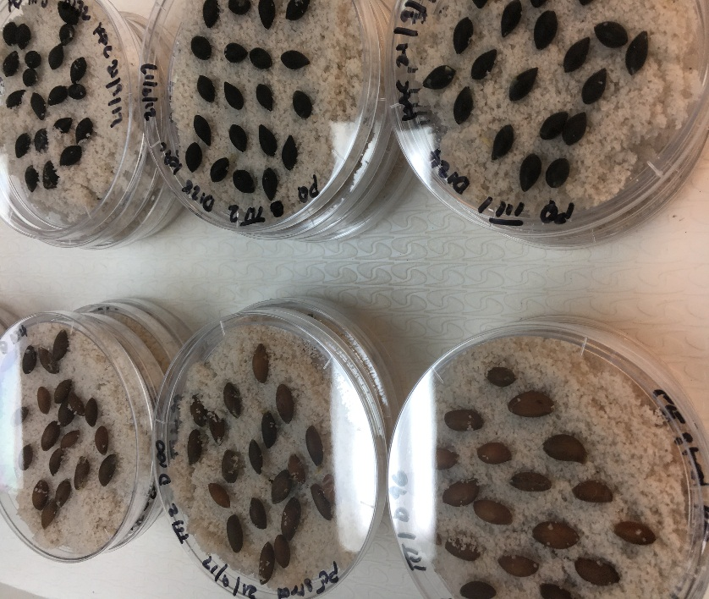
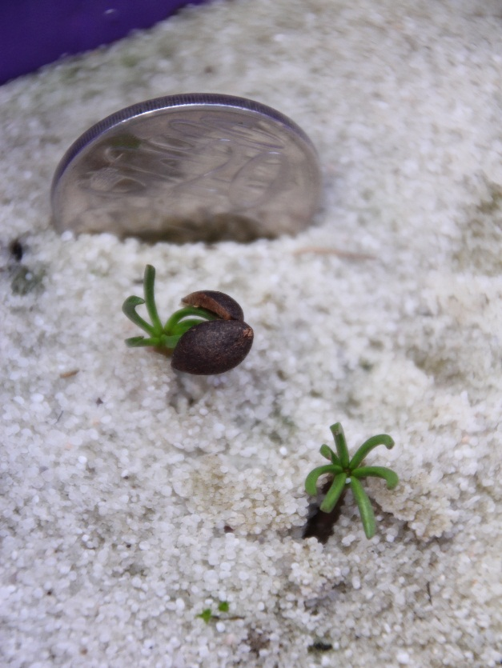
Persoonia elliptica
Laboratory trials
Persoonia quinquenervis seedlings in the nursery
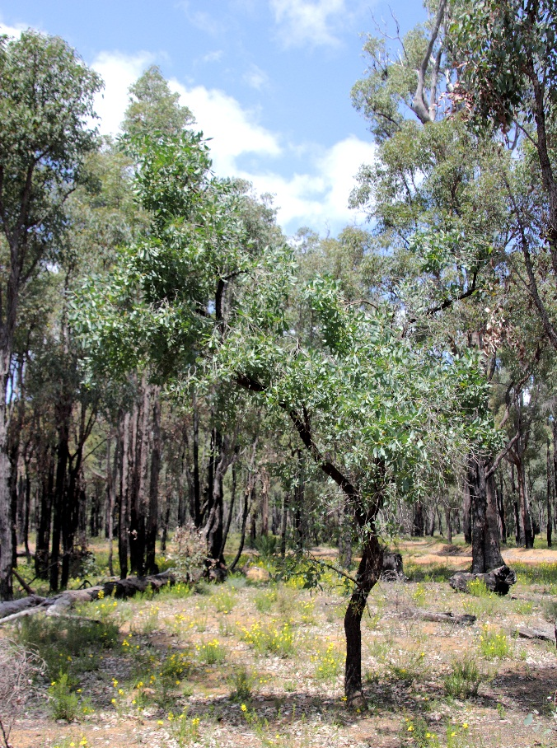
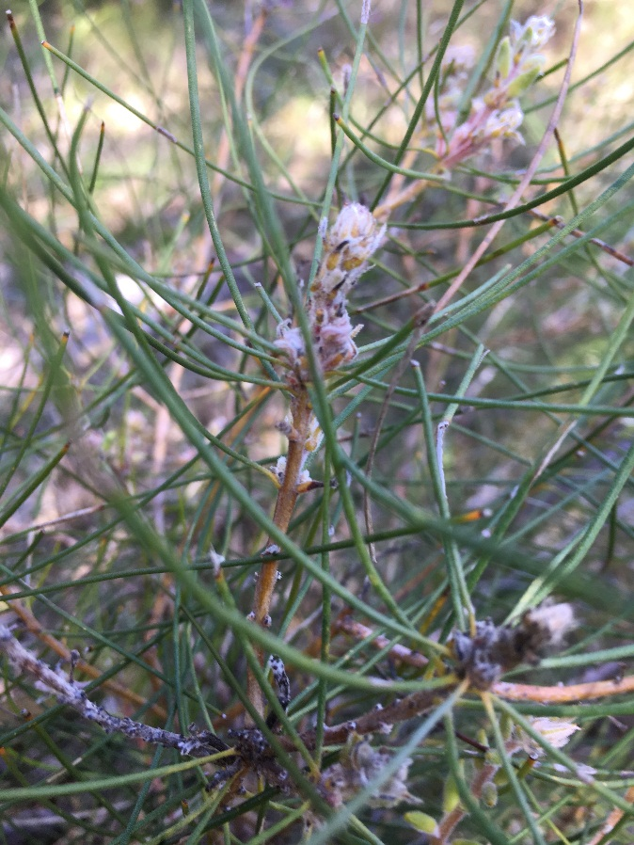
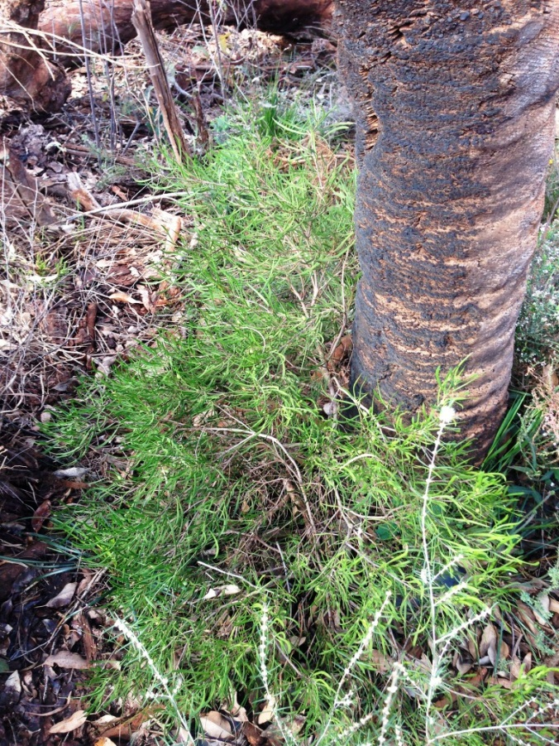
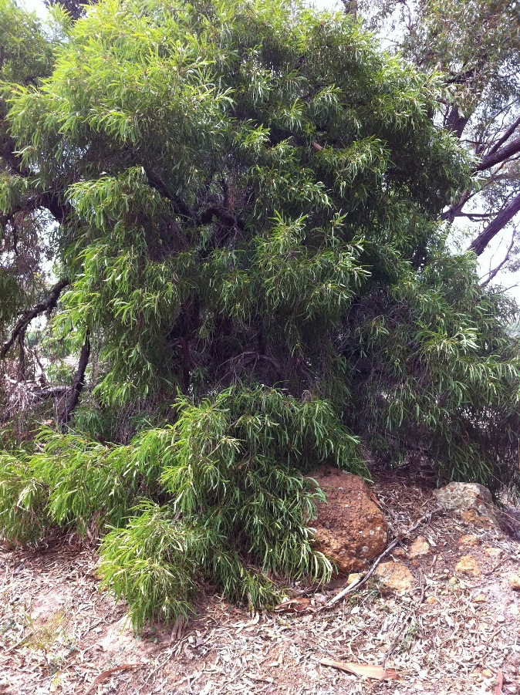
Persoonia elliptica
Persoonia saccata
Persoonia quinquenervis
Persoonia longifolia

