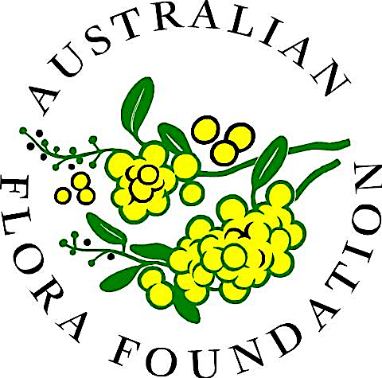 | A charity fostering scientific research into  the biology and cultivation of Australian flora  PO Box 846, Willoughby NSW 2068 Australia  ABN 14 758 725 506 https://aff.org.au/

Application for membership and renewal form

- Please enter your details (click in the grey boxes)

Dr/Mr/Mrs/Ms (your full name)

Street number and name

Suburb Postcode

Email Phone

☐ New member: I agree to be bound by the rules as expressed in the Memorandum and Articles of Association found on our website.

Renewing member: If any details have changed since your last renewal, please enter the new details above.

- Membership fee

$33 (including GST of $3), due each January $
Optional tax-deductible donation to fund Research $

TOTAL $

3. Payment
You can pay by direct deposit or cheque.
- Direct deposit to: Macquarie Bank, Australian Flora Foundation General Fund, BSB 182 222 Account no 116354465. Please reference your name
- Or cheque to Australian Flora Foundation Inc at PO Box 846, Willoughby NSW 2068
4. Finalising membership
Download this form and email to Heather Miles, Secretary at secretary@aff.org.au
Alternatively please print and post to Australian Flora Foundation Inc., PO Box 846, Willoughby, NSW 2068

We look forward to your participation in the Foundation.

